Anesthesia for high-risk procedures in the catheterization laboratory.
Daaboul DG, DiNardo JA, Nasr VG.
Paediatr Anaesth. 2018 Dec 28. doi: 10.1111/pan.13571. [Epub ahead of print]
PMID: 30592354
Similar articles

Take Home Points:
- While reported adverse events in the catheterization lab range between 4-10%, the prevalence of adverse events (4.2%) and all cause-mortality (12%) during the hospital stay is highest for neonates. In addition to the risk of the procedure itself, young age, pulmonary artery hypertension, diastolic dysfunction, low cardiac-output, cyanosis, and low mixed venous saturation may further increase the risk.
- Safe induction and maintenance of general anesthesia for high-risk cardiac catheterization require an understanding of the pathophysiology of each disease process, the planned procedure, its impact on the hemodynamics, the impact of the various anesthetic and pharmacologic interventions as well as experienced personnel and good communication between team members.

Commentary by Laura A. Downey, a pediatric cardiac anesthesiologist at Children’s Healthcare of Atlanta/Emory University: Recent advances in technology allow for more complex procedures to be performed in smaller patients in the cardiac catheterization laboratory. Multiple cardiology registries have been created to assess adverse events and assign risk scores to these patients. However, none of the developed scores specifically address anesthetic risk. Therefore, these authors discuss perioperative procedure and anesthetic-related risk assessment as well as the anesthetic approach for the management of neonates undergoing specific high-risk procedures in the cardiac catheterization laboratory.
The authors discuss several registries that cardiologists have used to risk stratify patients presenting to the catheterization lab, including two different risk scores. One such prediction model for high-severity adverse events is The Catheterization for Congenital Heart Disease Adjustment of Risk Method (CHARM), which uses procedure risk category, number of variables of hemodynamic vulnerability, and age <1 year. Incorporating the procedure risk group and hemodynamic variable in CHARM, the large IMPACT dataset was used to create a more generalizable model to predict major adverse events that included: procedure risk group, four hemodynamic vulnerability variables, age, the presence of renal insufficiency, and single ventricle physiology. Concurrent with the development of the CHARM model, the Congenital Cardiac Interventional Study Consortium (CCISC) group developed the Catheterization Risk Score for Pediatrics (CRISP). This scoring system assigns patients into one of five CRISP categories that assigns points based on weight, age, inotropic support/extracorporeal membrane oxygenation (ECMO), systemic illness/organ failure, physiological status, pre-catheterization diagnosis, procedure type, and the procedure performed. The risk of serious adverse events ranges from 1% for CRISP 1 and 36.8% for CRISP 5.

Despite the above models, neither of these developed scores specifically address anesthetic risk. Recently the C3PO database determined a 1.83% risk of overall sedation/airway related events and only 0.14% category 4 life threatening events and 0.014% category 5 catastrophic events (two cardiac arrests). Low patient weight (<4kg), lowed mixed venous saturation (single ventricles <50%, two ventricles < 60%), and the presence of additional non-cardiac comorbidities were correlated with high severity of sedation or airway anesthesia related complications. In light of these statistics and a paper that demonstrated the involvement of cardiac anesthesiologists lower the incidence of cardiac arrest from 3.5% to 0.7%, a 2016 expert consensus statement recommended that anesthesiologists with advanced skills and understanding of the pathophysiology and expertise in management of patients with CHD provide care for high-risk patients.
The authors discuss the importance of preparing for the unique challenges that anesthesiologists face in the cardiac catheterization laboratory: limited access to patients due to small workspaces and equipment, poor lighting, radiation exposure, offsite location, and potential difficulty in getting help fast. Low ambient temperatures and the frequent flushing of catheters and sheaths may result in hypothermia and volume load, especially in infants. Due to catheters crossing through the heart, risks include dysrhythmias, bleeding from perforation of heart structures or vessels, damage to valves, stroke and risk of air embolism. In order to prepare for a variety of potential complications, the authors recommend adequate IV access, readily available resuscitation drugs and defibrillation pads, easily accessible blood (the authors recommend cross-matched blood, however other institutions may use O-negative blood), and ECMO support if necessary.
Based on factors in the CRISP and CHARM models that predict adverse events, these authors specifically discuss perioperative concerns and anesthesia technique for interventional procedures performed in patients <1 year of age that present the highest risk of adverse events due to procedure and anesthesia-related risks: 1) Closure of a patent ductus arteriosus (PDA); 2) Ductal stent; 3) right ventricular outflow tract (RVOT) stenting; 4) Pulmonary atresia with intact ventricular septum (PA/IVS); 5) Valvotomy in critical aortic stenosis (AS).
- Patent Ductus Arteriosus (PDA) Closure

These authors summarize the recent literature regarding PDA device closure, specifically focusing on recent studies that demonstrate up to 88% success of PDA occlusion in preterm and low birth weight infants (mean age 30 days, mean weight 1249g) with very low complication rates. Although relatively safe, important complications include device embolization, ductal spasm, residual shunts, left pulmonary artery obstruction, development of aortic coarctation, and vascular injury. Ductal spasm, occurring in 2.1%-3.7% of closures, may result in failure of the procedure due to undersizing of the device and risk of embolization. For anesthesiologists, device embolization and retrieval may present the most challenging complication of this procedure, including possible hemodynamic instability, valvular damage, vascular injury, or emergent surgical intervention with cardiopulmonary bypass.

- Ductal Stenting

Traditionally achieved surgically with a Blalock Taussig (BT) shunt, creating a reliable source of pulmonary blood can now be achieved in the cardiac catheterization laboratory with ductal stenting. When ductal stenting is compared to a BT shunt, patients receiving a ductal stent had lower complication rates, shorter length of stay (LOS) in the intensive care unit (ICU), and more symmetrical pulmonary artery (PA) growth (Glatz et al), while a similar study found shorter mechanical ventilation times, shorter ICU LOS, and less ECMO. Both studies found that ductal stent patients had a higher rate of reintervention, unrelated to cyanosis. Important anesthetic considerations for patients receiving ductal stents, include appropriate discontinuation of prostaglandin E₂ to allow the ductus to be small enough to wedge the stent in place, but not so small that pulmonary blood flow (PBF) is compromised. During the procedure, anesthesiologists should be prepared to support hemodynamic changes during complete or partial occlusion of the ductus due to catheter manipulation or ductus spasm. Occasionally, the stent may not be able to be deployed or hypoxemia persists despite stent deployment and surgical intervention to place a shunt may be required.
- RVOT Stenting

Advances in the catheterization lab make RVOT stenting and balloon dilation of the pulmonary valve a reasonable alternative for patients with RVOT obstruction (i.e. TOF patients). This approach is most beneficial in premature or low birth weight patients, who have the highest operative morbidity and mortality. When compared to a BT shunt, the RVOT stent group had shorter time to surgical repair (232 days versus 428 days), lower intensive care admission rate (22% versus 100%) and shorter length of stay (median 7 days versus 14 days). Procedure-related complications include perforation of the pulmonary artery or RVOT leading to hemothorax and pericardial effusion, stent embolization, or tricuspid valve regurgitation. Anesthesiologists should be prepared for possible hemorrhage due to RVOT or PA perforation with immediate access to red blood cells and adequate IV access. Transient pulmonary edema may occur during the procedure due to the sudden increase in pulmonary blood flow. Pulmonary edema should be treated with positive end-expiratory pressure (PEEP) and diuretics and admission to the ICU should be considered.
- Pulmonary Atresia with Intact Ventricular Septum

Patients with PA/IVS require PGE₂ to maintain ductal patency and pulmonary blood flow. These patients are often taken to the catheterization laboratory early to determine if the patient has RV-dependent coronary circulation (RV-DCC). In patients without RV-DCC, the pulmonary valve can be opened with radiofrequency (RF) perforation and stented. RF of the pulmonary valve is contraindicated in patients with RV-DCC who require PDA stent placement, BT shunt placement, or transplantation. Mortality is estimated at 6.69%. As these patients are at risk for sub-endocardial ischemia, RV preload and systemic diastolic pressure must be adequate to maintain coronary perfusion. Common complications are similar to patients undergoing RVOT stenting, including perforation of the PA/RVOT. Atrial and ventricular arrhythmias and heart block are likely related to coronary ischemia. Anesthesiologists must, therefore, be prepared for emergent transfusion or cardioversion in these procedures. In the setting of borderline RV function, pulmonary blood flow may not be sufficient and PGE₂ will need to be started.
- Critical Aortic Stenosis

Of the 6% of patients with left ventricular outflow obstruction (LVOTO), aortic stenosis accounts for approximately 80% of these cases. Neonates with critical AS usually present with signs of hypoperfusion, cyanosis, and lethargy as the ductus begins to close. Thus, prostaglandins are started in order to maintain ductal patency and systemic perfusion. Balloon valvotomy has been shown to decrease the aortic gradient by 50%, but with a 15% risk of aortic regurgitation (AR). Many of these patients will present for surgical intervention for AR or re-intervention for recurrent stenosis. Procedure risks include arrhythmias and perforation. During balloon dilation, cardiac arrest may occur due to cessation of cardiac output. In addition to preparation for hemorrhage, arrhythmias, or cardiac arrest, the goal of the anesthetic is to maintain coronary perfusion and cardiac output. The authors recommend an opioid-based anesthetic with readily available inotropic support, such as epinephrine.
As demonstrated by the above discussion, safe induction and maintenance of general anesthesia for high-risk cardiac catheterization require an understanding of the pathophysiology of each disease process, the planned procedure, its impact on the hemodynamics, the impact of the various anesthetic and pharmacologic interventions as well as experienced personnel and good communication between team members.

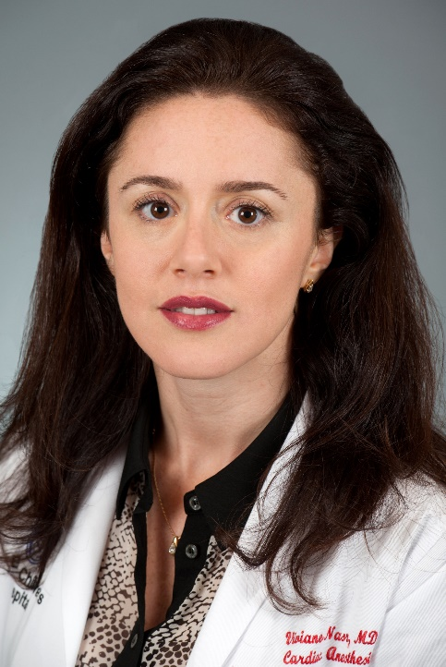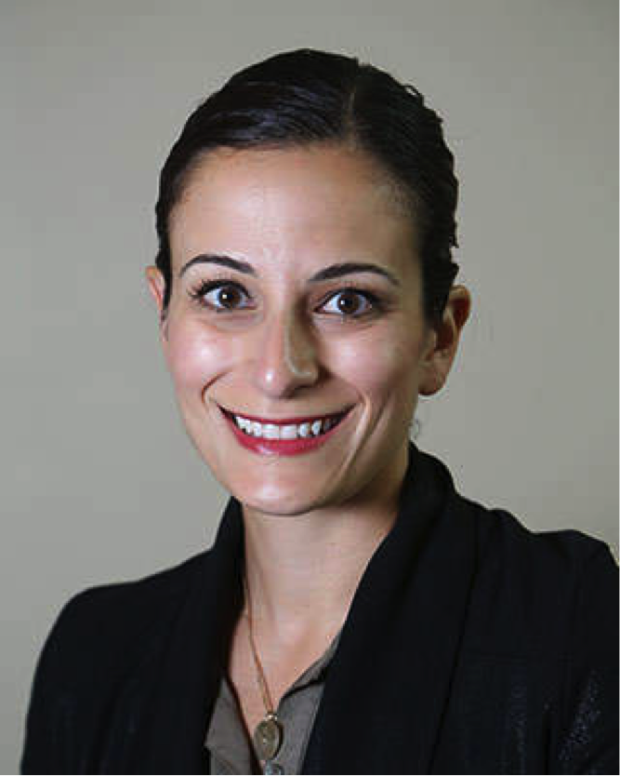
Viviane Nasr (Boston) and Rania Abbasi (Indianapolis) – Section Editors

