Echocardiographic Assessment of Cardiac Function in Pediatric Survivors of Anthracycline-Treated Childhood Cancer.
Slieker MG, Fackoury C, Slorach C, Hui W, Friedberg MK, Fan CS, Manlhiot C, Dillenburg R, Kantor P, Mital S, Liu P, Nathan PC, Mertens L.
Circ Cardiovasc Imaging. 2019 Dec;12(12):e008869. doi: 10.1161/CIRCIMAGING.119.008869. Epub 2019 Dec 12.
PMID: 31826678
Similar articles
Select item 31766863

Take Home Points:
- Longitudinal strain is only mildly reduced in pediatric childhood cancer survivors (CCSs) and associated with age at the time of the study and higher body surface area.
- Left ventricular ejection fraction is preserved in the majority of CCSs.

Commentary from Dr. Inga Voges (Kiel, Germany), section editor of Pediatric Cardiology Journal Watch: This large multicenter study included 546 pediatric childhood cancer survivors (CCSs)and assessed if echocardiographic strain parameters are of utility for the identification of patients at risk for cardiac dysfunction. Echocardiographic examinations included assessment and calculation of cardiac chamber size, left ventricular (LV) systolic and diastolic function and ventricular mass. Speckle tracking echocardiography was used to measure LV strain parameters. Patients were compared to 134 healthy controls.

The median age and median time from last anthracycline dose were 13.8 years and 7.9 years respectively; all patients were asymptomatic. Compared to controls, CCSs had lower LV ejection fraction (LVEF) and fractional shortening. LV dilatation was only found in 1 patient. Reduced EF with values below 50% were found in 0.8% (n=3) of all patients and 4.2% had values between 51% and 55%. Regarding parameters of diastolic function, the authors found an increased isovolumetric relaxation time in CCS compared to controls.

Global longitudinal strain (GLS) was significantly lower (Figure 1) and circumferential strain (CS) was significantly higher in patients, but the absolute difference was small for both parameters. Lower mean longitudinal strain was associated with lower LVEF in both, patients and controls (Figure 2). Patients with low LS Z-scores had significantly lower CS values.

In multivariable regression analysis age and body surface area were significantly associated with lower mean LS Z-scores. Patients who received a cumulative anthracycline dose of <150 mg/m² compared to those with a dose >150 mg/m², there was no difference between patients who received a dose between 150 mg/m² -300 mg/m² and those who received a cumulative dose >300 mg/m2.

Overall, the results are interesting, especially for the pediatric cohort of childhood cancer survivors.

Figure 1
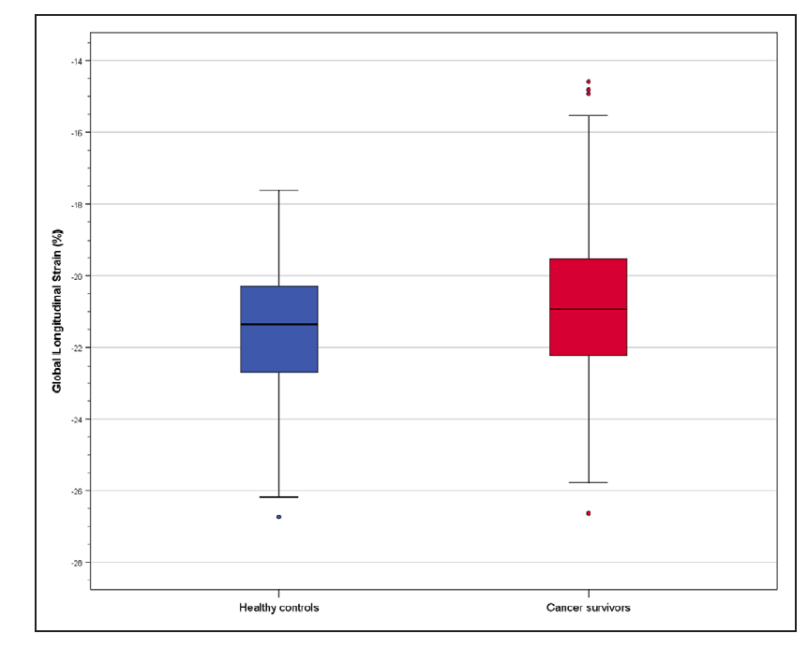

Figure 2
