Eligibility for subcutaneous implantable cardioverter defibrillators in the adult congenital heart disease population.
Garside H, Leyva F, Hudsmith L, Marshall H, de Bono J.
Pacing Clin Electrophysiol. 2019 Jan;42(1):65-70. doi: 10.1111/pace.13537. Epub 2018 Dec 4.
PMID: 30394548
Similar articles
Select item 30394546

Take Home Points:
- Adult congenital heart disease (ACHD) patients may need implantable cardioverter-defibrillators (ICDs) due to concerns for life-threatening arrhythmias and increased risk for sudden cardiac arrest.
- The use of traditional transvenous ICD systems may not be a viable option in a subset of ACHD patient due to lack of vascular access associated with underlying anatomy or concerns for short and long term procedural risks.
- Subcutaneous ICDs (S-ICD) provide a new and less invasive approach to provide similar protection in these complex patients, but its use has been limited.
- Factors that have reduced the use of S-ICDs include the need for concurrent pacing.
- This study showed that 25% of patient with ACHD - TOF, TGA, Fontan - are deemed ineligible for S-ICD placement due to failure to pass the S-ICD ECG screening test which is required for the device to appropriately detect arrhythmias.
- 9 out of 10 Fontan patients meet S-ICD screening eligibility which is encouraging for a population with limited vascular access and negative long-term implantations associated with a transvenous ICD system.
- The presence of TOF, RBBB, and prolonged QRS duration were associated with ineligibility.
- The R wave sensing varied significantly with position.
- Prior studies have shown that exercise also negatively impacted appropriate sensing which was seen here.
- Rigorous pre-screening for S-ICD eligibility should be performed to avoid the risk of inappropriate shock delivery or withholding.
Commentary by Dr. Akash Patel (San Francisco, CA) Congenital and Pediatric Cardiac EP section editor: Based on the 2014 HRC/PACES Expert Consensus Statement on the Recognition and Management of Arrhythmias in Adult Congenital Heart Disease recommends ICD implantation in ACHD patients with prior cardiac arrest, hemodynamically significant ventricular arrhythmias, significantly depressed ventricular function, and in select high-risk patient groups such as TOF. The vast majority of adult patients requiring ICD therapy have structurally normal hearts with normal cardiac position in the chest for whom the S-ICD was developed. This may not be the case for ACHD patients with complex anatomy, abnormal cardiac position, and abnormalities in conduction system that may impact the efficacy of the S-ICD. Prior small series have looked at ACHD patients who have received S-ICD which as you expect consisted of small heterogeneous populations. The aim of this study was to determine the proportion ACHD patients with TOF, D-TGA, or Fontan Palliation who met the ECG screening criteria for an S‐ICD in a larger cohort. The secondary aim was to determine factors that may impact eligibility status.
The study was a single center prospective cohort study conducted at a specialized ACHD Center (UK). All patient ≥ 16 years of age with tetralogy of Fallot, d-transposition of the great arteries, or Fontan palliation were included.

All subjects underwent screening ECG via the S-ICD manufacturer’s protocol using modified electrode positions. Three vectors were analyzed - primary, secondary, and alternate (See below) in three positions- supine, sitting, and standing. The external screening ECG was recorded for up to 10s at 25 mm/s with gains of 5, 10, or 20 mm/mV. This was repeated post-exercise for patients who had an exercise test as a part of their routine ACHD care.
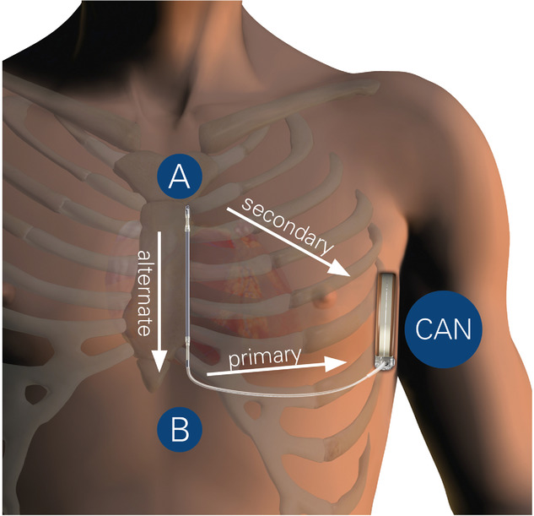

Based on the analyzed signal, the obtained screening ECG would be deemed acceptable or not based on the manufacturer algorithm (see below). In addition, 12-lead ECG data was extracted. This included assessment of the R:T_{max} which was defined as the ratio of the R wave to T wave in the lead with the largest amplitude T wave.
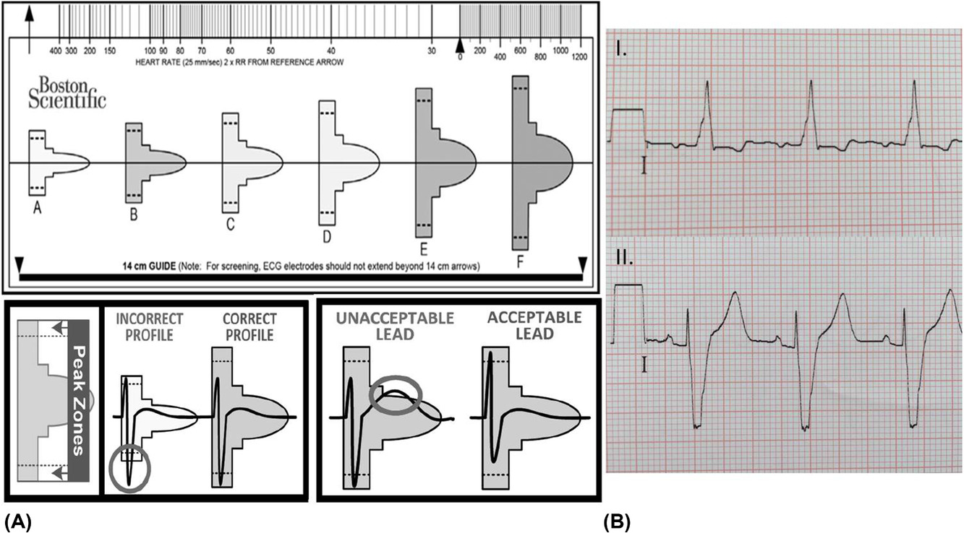

There were 102 of 107 recruited subjects who had complete data. The average age was 30.7 ± 6 years. At baseline, 77 (75%) passed screening eligibility for S-ICD and 25 (25%) were deemed ineligible. There were only 14% of patients who had screening repeated post-exercise.
Comparison between eligible and ineligible patients showed no difference in age, sex, or BMI.
The underlying anatomy included Fontan (22%), TGA (34 %), TOF (38%), Fontan+TGA (5%), TOF + Fontan (1%). There was no difference between eligible and ineligible groups for TGA , Fontan+TGA ,and TOF+Fontan group. TOF resulted in more ineligible patients (56% vs 33%). Fontan palliation resulted in more eligible patients (27% vs 4%). Of note, 5% had dextrocardia. (See Below)

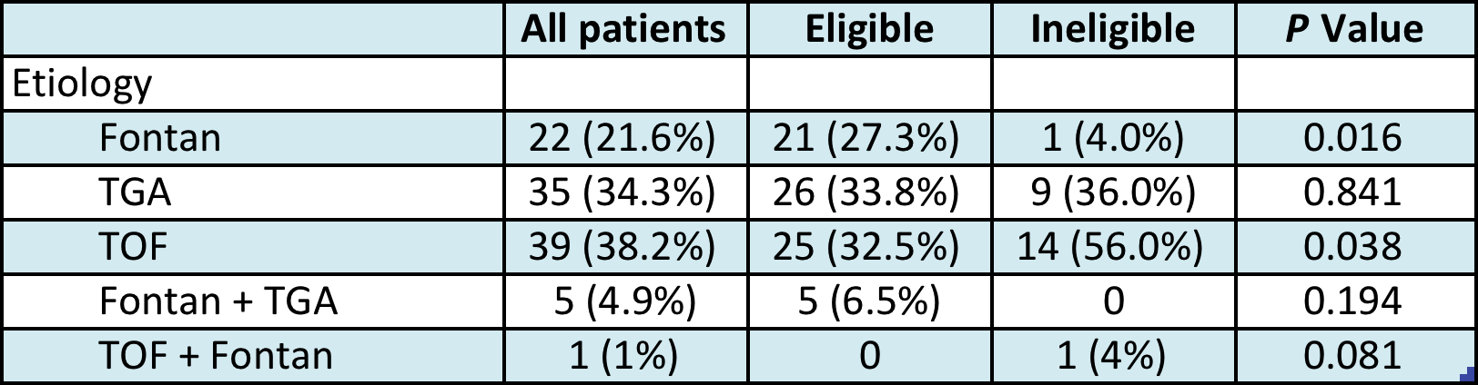

The baseline ECG characteristics showed 69% had a bundle branch block (BBB) of which 84% were Right BBB. Prolonged QRS duration (149 msec vs. 122 msec) and RBBB (68% vs 44%) were significantly associated with the ineligible group. Narrow QRS duration (<120 msec) was significantly associated with the eligible group (47% vs 20%). (see below)

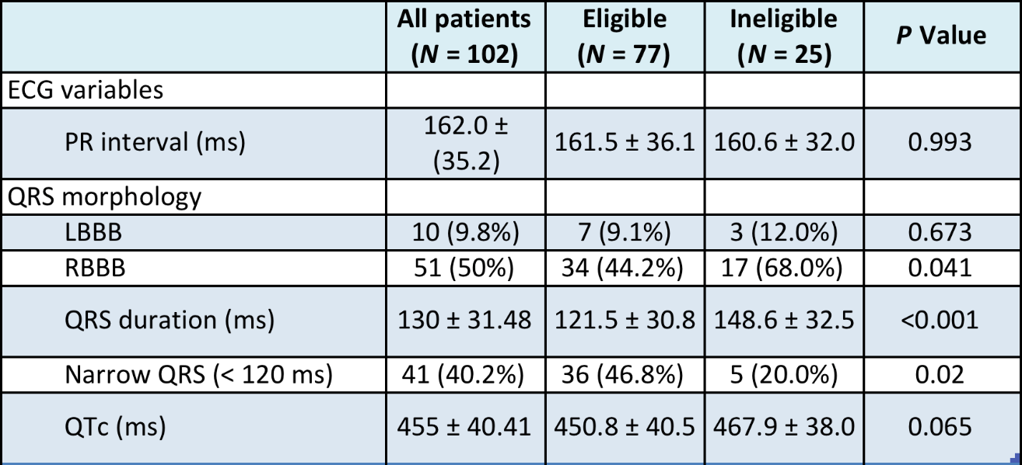

The R wave amplitude varied significaly with position with larger R waves seen in the eligible group. (See below)
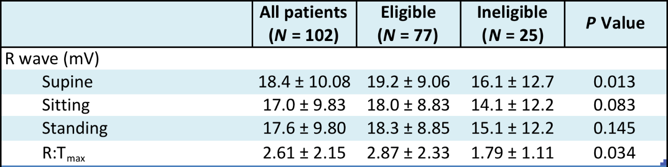
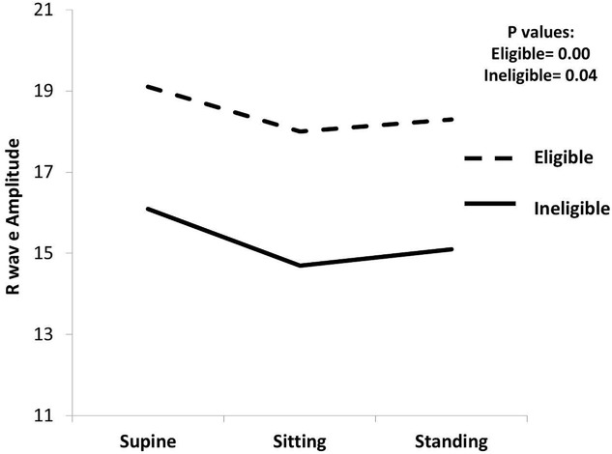

Eligibility was noted in 77 (75%) of patients with at least one suitable vector. One suitable vector was seen in 38%, two suitable vectors in 47%, and all there in 16%. The primary vector was suitable in 62% (see initial figure).
Ineligibility was noted in 25% of patients and differed by anatomy as mentioned. (see below). The main reason for differences was felt due to the R:T max changes with position. The reasons for ineligibility, if they failed all 3 vectors was due to a Tall T waves .

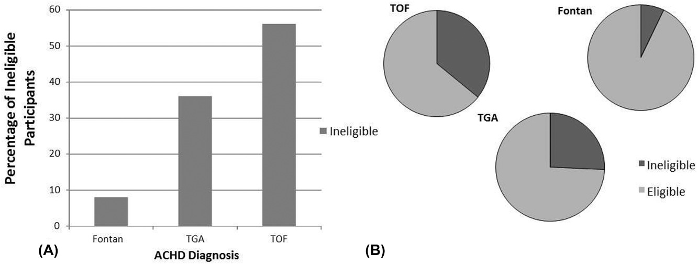

Of the 14 patient who were rescreened after exercise stress tests, 1 failed to maintain eligibity. This patient had TOF.
There was no multivariate analysis to further delineate the variable associated with eligibility status.
This study showed that 25% of ACHD patients with TOF, Fontan, TGA or some combination of these select anatomies failed to meet S-ICD eligibility criteria. Patients with TOF were the group that failed the screening in the highest proportion (36%) which is likely due to the presence of a prolonged QRS and RBBB. Fontan patients on the other had were deemed eligible in the vast majority (90%). Due to the impact of anatomy, positional changes and exercise on R/T wave analysis, presence of BBB, and secondary abnormal repolarization (i.e. Tall T waves), the eligibility for S-ICD in ACHD is limited. Additional work on refining algorithms, use of additional screening ECG vectors and alternative device position placement, and more rigor at time of patient selection will ultimately provide for increased eligibility and better patient selection of S-ICDs in ACHD patients.

