Exercise Capacity in Asymptomatic Adult Patients Treated for Coarctation of the Aorta.
Dijkema EJ, Sieswerda GT, Breur JMPJ, Haas F, Slieker MG, Takken T.
Pediatr Cardiol. 2019 Oct;40(7):1488-1493. doi: 10.1007/s00246-019-02173-5. Epub 2019 Aug 7.
PMID: 31392380 Free PMC Article
Similar articles
Select item 31367952

Take Home Points:
- Exercise capacity was normal in a small group of adults > 20 years post repair of coarctation of the aorta.
- Resting hypertension was present is 59 % (13/22) while exercise-induced hypertension was detected in 82 % (18/22).
- Amongst normotensive subjects, exercise-induced hypertension occurred in 78 % (7/9).
- Surveillance of exercise-induced hypertension with cardiopulmonary exercise testing as a precursor to chronic hypertension can be considered for its early detection.

Commentary from Dr. Timothy Roberts (Melbourne, Australia), section editor of ACHD Journal Watch: Exercise capacity is reduced in adults with congenital heart disease (CHD), although those with repaired coarctation of the aorta (CoA) are thought to have the least – if any – impairment relative to other forms of complex CHD. Meanwhile hypertension remains a lifelong risk in repaired CoA, due to reduced aortic compliance, impaired baroceptor function, and abnormal wall-shear stress dynamics. Isolated exercise-induced hypertension may be a predictor for the future development of chronic hypertension.

The aims of this singe centre prospective study were to assess (1) exercise capacity, and (2) blood pressure response in adults with repaired CoA in relation to left ventricular and vascular function.
Study participation involved cardiopulmonary exercise testing (CPET) and cardiac MRI. Inclusion criteria were a history a CoA with primary treatment (surgical or balloon angioplasty without stenting) performed between ages 3 months to 16 years, and more than 10 years of follow-up. Exclusion criteria were isthmus or aortic arch hypoplasia, and severe associated CHD lesions. A ‘control group’ for exercise data was constructed using a large Dutch database.
A total of 72 patients met criteria, of which only 22 (31 %) agreed to participate. Patient demographics, and CPET results are shown in the tables below:
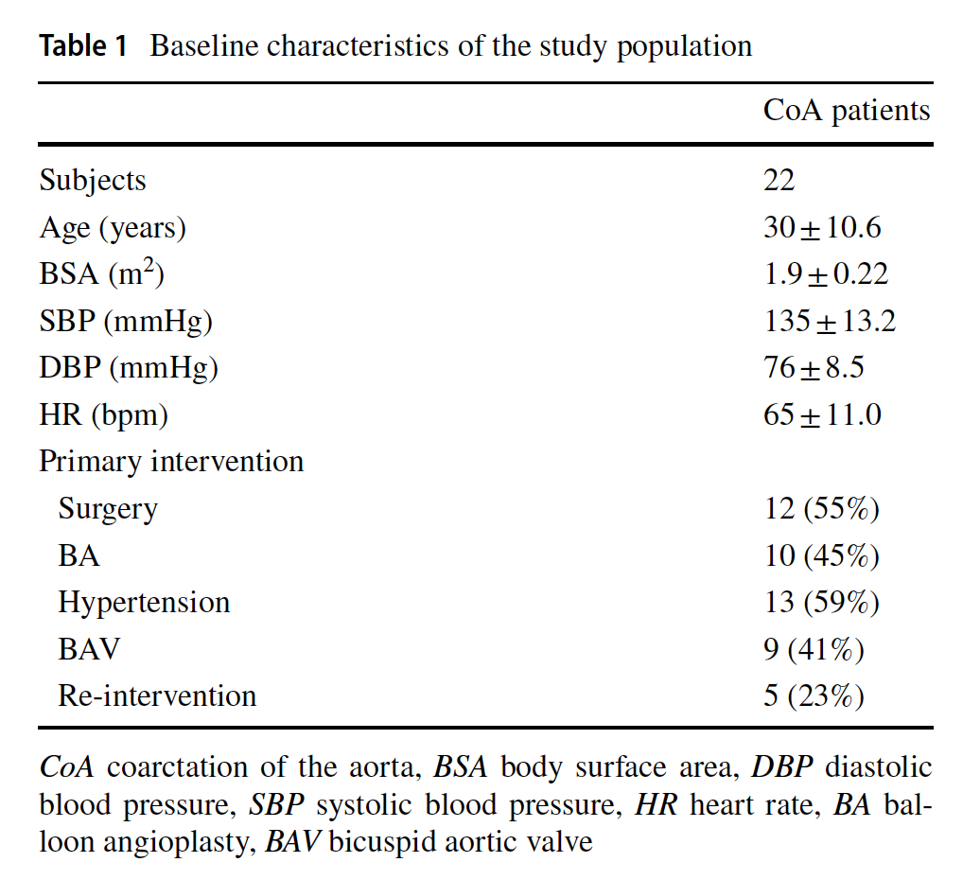

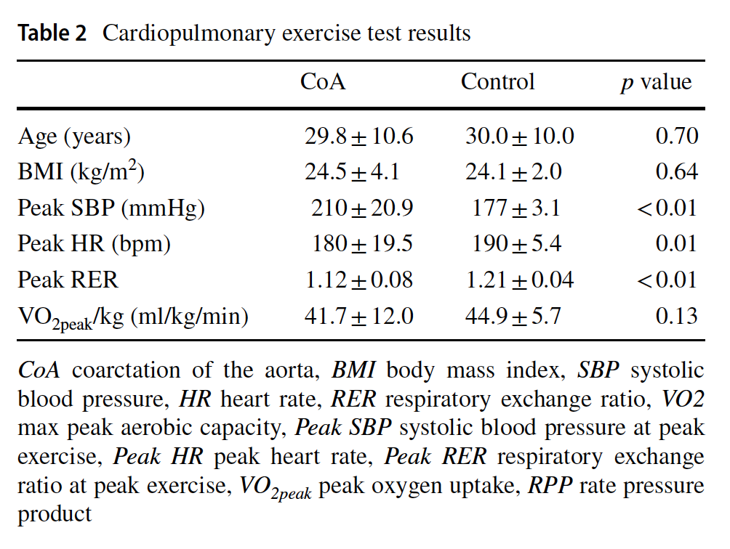
Exercise capacity was normal (VO_{2peak} 41.7 +/- 12 ml/kg/min) in the CoA cohort. Exercise-induced hypertension was common (82 %), and of the 9 normotensive subjects, 7 (78 %) demonstrated exercise-induced hypertension. Peak exercise blood pressure was correlated to LV mass, 24-hour ambulatory systolic blood pressure, and systemic hypertension. Multiple regression analysis was attempted to identify predictors of VO_{2peak} and not surprisingly identified male sex and age as significant predictors; a number of additional factors were included but the small sample size would make it highly unlikely to find additional significant associations (whilst being statistically inappropriate).
This study is limited by the small sample size, low recruitment rate, inevitable risk for selection bias in an exercise-based study, and the absence of a true control cohort. Nevertheless, it does demonstrate a large proportion of normotensive repaired CoA subjects to display exercise-induced hypertension. Although the significance of such a finding remains debated, these patients may benefit from more frequent blood pressure assessments to enable earlier detection of chronic hypertension. Exercise testing to assess for exercise-induced hypertension carries a Class IIb recommendation in the 2018 AHA/ACC Guidelines for the Management of Adults With Congenital Heart Disease.

