Exercise stress echocardiography: Impact on clinical decision-making in pediatric patients.
Dasgupta S, Friedman H, Allen N, Stark M, Ferguson E, Sachdeva R, Border WL.
Echocardiography. 2019 May;36(5):938-943. doi: 10.1111/echo.14326. Epub 2019 Apr 1.
PMID: 30934142
Similar articles
Select item 30801777

Take Home Points:
- Stress echo may be a helpful adjunctive modality in assessing pediatric patients and aid in the decision making process for exercise permission or restriction
- Additional studies will be necessary to determine how well and in which patient subgroups stress echo will be helpful beyond the data obtained from the (metabolic) stress test itself

Commentary from Dr. Jared Hershenson (Greater Washington DC), section editor of Pediatric Cardiology Journal Watch: Exercise stress echocardiography (ESE) is not a commonly used modality in pediatric patients and there are few published studies reporting the utility of ESE in this population. ESE is commonly used to assess cardiac function in adults with coronary issues, hypertrophic cardiomyopathy (HCM), aortic valve disorders, and EKG abnormalities (e.g. LBBB), but some pediatric labs have started to use ESE in pediatric patients with many of the above issues. The primary aim of this study was to evaluate the utility of ESE in a large single pediatric program and a secondary aim was to see how ESE impacted clinical management.

Test indications were divided into 5 categories: 1) symptoms with exercise, 2) sports/activity clearance, 3) HCM, 4) coronary abnormalities, and 5) abnormal EKG. It was not clearly stated, but patients with pre-existing CHD (besides coronary anomalies) were seemingly most often included in the 1st and 2nd categories. Most patients had ESE with a cycle ergometer at this center due to easier ability to acquire images (a few used a treadmill with a standard Bruce protocol). A James protocol was used, and images were obtained at each stage and immediately after peak. Tests were classified as either normal or abnormal with the latter further being classified as revealing a structural or functional defect or worsening severity of an existing diagnosis. Outcomes of the test were classified as no change in clinical management, change in clinical management, or unknown. If there was a change, the EMR clinical information was reviewed to determine if someone was restricted from activity, released from restrictions, or if there was a surgical/interventional referral.
353 ESE’s met inclusion criteria and the mean age of the patient cohort was 13.9 +/- 3.3 years. Table 1 shows patient demographics and diagnoses.
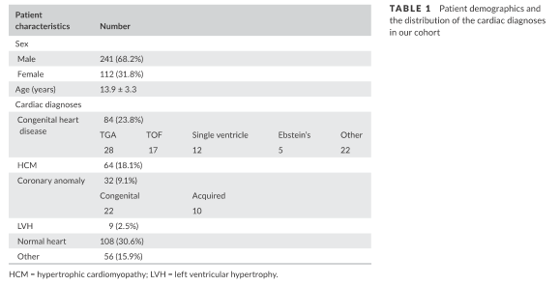

75% (263) of tests were normal. 23 patients with a normal ESE did not have follow up clinic visit documentation so a change in clinical management could not be determined for them. Clinical management changed as a result of the ESE in 144 (40%) patients (see Figure 1).
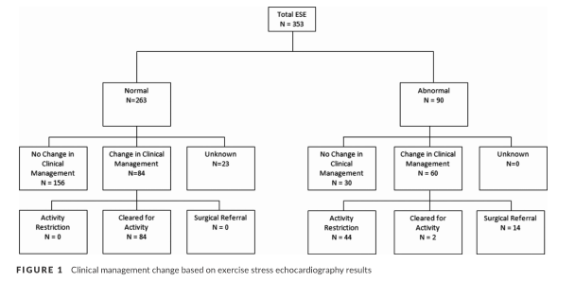

90 patients had an abnormal ESE with 2/3 undergoing a change in clinical management (nearly all were restricted). Among those restricted, 57% were for competitive sports, 32% for all activities but recreational, and 11% all activity. Table 3 shows this is more detail and Table 4 shows specific findings on the ESE that apparently warranted the restrictions. 7 patients had surgical or interventional referrals.
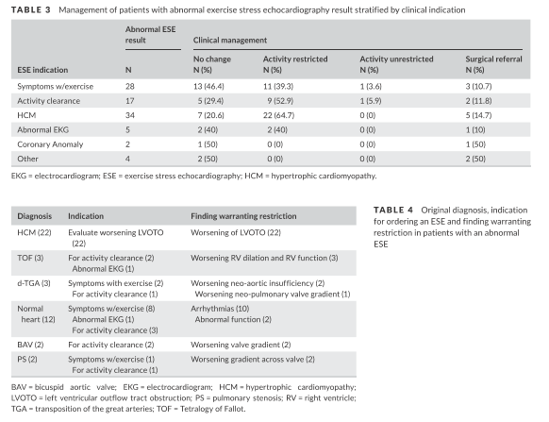

This study is mostly a descriptive study of use of ESE at a large pediatric center. While very interesting and novel, the indications for ESE use at this center seem to be non-traditional, and further data would be necessary to determine if and when other centers should perform ESEs. A significant major limitation in this study is that the exercise stress test data was not included in the analysis. Especially with metabolic data (CPET), it is possible that other variables may have been at least as important and perhaps more so in determining clinical management changes. It is also possible that many of the clinical management decisions could have been made without ESE, and the authors do not give insight how ESE exclusively would have been helpful in their patient population except in a handful of patients. In particular, I could imagine that many patients with a normal CPET may have been cleared without the ESE and many with certain diagnoses restricted without ESE (based on current clearance guidelines). I look forward to future analyses from this center, hopefully incorporating more robust CPET data and perhaps looking at ESE use in a larger number of patients within a specific subgroup.

