# [Heart or heart-lung transplantation for patients with congenital heart disease in England.](https://www.ncbi.nlm.nih.gov/pubmed/30636220)

Dimopoulos K, Muthiah K, Alonso-Gonzalez R, Banner NR, Wort SJ, Swan L, Constantine AH, Gatzoulis MA, Diller GP, Kempny A.

Heart. 2019 Apr;105(8):596-602. doi: 10.1136/heartjnl-2018-313984. Epub 2019 Jan 12.

PMID: 30636220

**Take Home Points:**

* Retrospective analysis of patients with congenital heart disease who underwent heart or heart-lung transplantation between 1997-2015 in England, UK.
* Over an 18 year period, in 444 patients, there were 469 transplants - 83% heart and the remainder heart-lung.
* The majority of first heart or heart lung transplants were performed in patients <18 yrs. old (53%). The median age at transplantation was 19.5 years (range 0-63.6 years)
* Just over half of all transplants (54%, n=239) were in patents with complex congenital heart disease.
* Of patients undergoing heart-lung transplantation, 92% had complex congenital heart disease. Comparatively, of those patients undergoing heart transplant alone, 46% were complex and the remainder mild or moderate.
* Older age and heart-lung transplant were strong predictors of death.
* Although there is an increasing need for transplantation in the congenital cardiac population there is a supply-demand mismatch, which is ever widening.



***Commentary by Dr. Damien Cullington (Liverpool, UK), section editor of ACHD Journal Watch:*** Heart failure is the leading cause of demise in the adult congenital cardiac population. Surgical, interventional, device and medical treatments have become ever more ambitious and proactively pursued both by clinical teams. Naturally, there is an ever increasing number of ACHD patients who are palliated for their condition and who eventually need assessment for their suitability for advanced heart failure therapies. The biggest difficulty we are facing is an adequate supply of donor organs for the ever increasing demand in the congenital population. In addition, for our patients with a Fontan, there is the further complex issue of the potential for heart-liver transplantation due to insidiously progressive Fontan associated liver disease.

*Dimopoulos et al.* published this UK retrospective analysis of the Hospital Episode Statistics database of all patients with a code for congenital heart disease who have underwent heart or heart-lung transplant between 1997-2015 in England. The baseline characteristics of the population are shown in **Table 1**. The annual number of heart and heart-lung transplants performed and the age distribution at the time of transplant is shown in **Figure 1.**





**Transplant numbers and projections for the future**

**Figure 1** shows that following an unexplained drop in transplant numbers in 2003, there has been and increasing number of heart transplants with a declining number of heart-lung transplants. The proportion of adult-to-paediatric transplants is essentially unaltered over time. Over the next decade, it is projected that there will be an increase by about a third of the number of heart and heart-lung transplants (**Figure 2A**). **Figure 2B** demonstrates the clearly evolving supply-demand mismatch between 2004-14 of an increasing number of AHCD patients hospitalised with heart failure with no corresponding increase in the number of transplants.

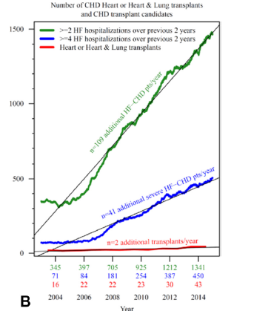

**Survival post transplantation (Figures 3A and 3B)**

In the combined heart and heart-lung first transplant population (n=444), over a median follow up of nearly 5 years, 29% of patients (n=130) died. In patients who had only a heart transplant, 30 day, 1, 5 and 10 year mortality was 11%, 14%, 21% and 27% respectively. At the same time interval, for patients undergoing heart-lung transplantation, mortality was 19%, 30%, 38% and 55%. Interestingly, for patients undergoing heart transplant, the complexity of congenital heart disease had no significant influence on survival. From the immediate time of transplant, children (<18 years old) had better survival than adults (15 year survival 67% vs 53%, p=0.01). In survivors after one year, there was no significant difference in survival between children or adults after transplant 74% vs 66%, p=0.66). **Figures 3A and 3B** show Kaplan-Meier curves for patients undergoing heart and heart-lung transplant from the time of transplant as baseline and 1 year following transplant as baseline.

