Long term follow-up after ventricular tachycardia ablation in patients with congenital heart disease.
Yang J, Brunnquell M, Liang JJ, Callans DJ, Garcia FC, Lin D, Frankel DS, Kay J, Marchlinski FE, Tzou W, Sauer WH, Liu B, Ruckdeschel ES, Collins K, Santangeli P, Nguyen DT.
J Cardiovasc Electrophysiol. 2019 Sep;30(9):1560-1568. doi: 10.1111/jce.13996. Epub 2019 Jun 11.
PMID: 31111602
Similar articles
Select item 31115957

Take-Home Points:

- This was a large two-center study of CHD VT ablation with 5-year follow up data.
- The mechanism of VT in congenital heart disease was primarily scar-related reentry (80%), followed by focal (15%) and non-scar related reentry (5%).
- Scar-related reentry was more commonly seen among patients with TOF vs other CHD anatomies.
- Acute complete procedural success could be achieved in 75% of patients overall, with recurrence in 20% of patients.
- Acute procedural success was strongly associated with ventricular arrhythmia-free survival.

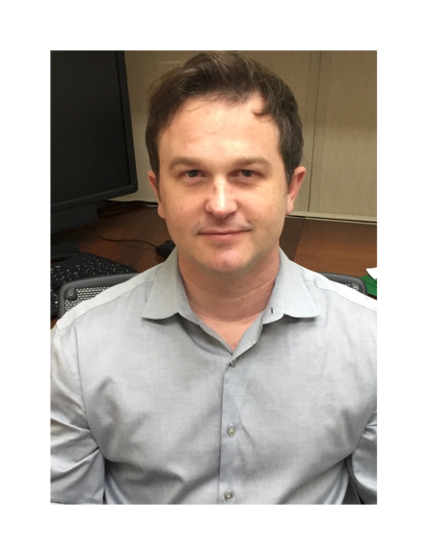Commentary by Dr. Jeremy Moore (Los Angeles) Congenital and Pediatric Cardiac EP section editor: This was a retrospective two-center study of VT catheter ablation outcomes over a 7-year period from 2010 to 2017. Forty-eight patients with variable CHD anatomy were identified, most commonly TOF in 29 (60%), Ebstein’s anomaly in 4 (8%), and bicuspid aortic valve in 4 (8%). Approximately three-quarters had an ICD in place and half had failed antiarrhythmic drugs. Overall, 77 unique VTs were induced, of which approximately half (52%) were hemodynamically stable and could be localized with activation or entrainment mapping. The remainder were identified by pace mapping. The mechanism was scar-related reentry in 81%, non-scar (His-Purkinje)-related reentry in 16%, and focal (mainly outflow tract in 73%) in the remaining 4%. His-Purkinje reentry (4) was seen only observed among patients with Ebstein’s anomaly (2) and TOF (2). Interestingly, the authors noted that VT CL was shorter for patients with preserved RV function versus RV dysfunction (286 ± 7 ms vs 322 ± 18 ms; P = .0246). In addition, TOF patients were more likely to manifest scar-related reentry.
Acute success was achieved in 75% of patients, with recurrent VT in 21% over nearly 5-year follow up. Patients with acute success were less likely to experience recurrent VT (17% vs. 54%, p=0.02). Five of 10 patients with recurrence were taken for a second catheter ablation procedure. In 1 patient, the same anatomical isthmus was targeted; and in 2 others, a separate site was targeted (right coronary cusp in 1 and RBB in 1). The final 2 patients had no inducible VT at repeat catheter ablation and substrate-based ablation was pursued. There were no major complications from catheter ablation. At last follow up, only 8 patients remained on antiarrhythmic drugs.

This study is notable as it is the largest series to date, describing catheter ablation outcomes in mixed CHD cohort with VT. The acute efficacy of 75% with no major complications suggest that this approach is a very reasonable therapeutic modality for affected patients. Similar to a smaller prior description from the Mayo Clinic [Martin et al. Heart Rhythm 2016;13:1449-1454), mechanisms were predominantly scar-related and anatomically based, with a significant number of focal VTs. Although reassuring, the issue of catheter ablation as a substitute for ICD placement was not fully resolved from this interesting experience.

