Long-Term Survival of Patients With Coarctation Repaired During Infancy (from the Pediatric Cardiac Care Consortium).
Oster ME, McCracken C, Kiener A, Aylward B, Cory M, Hunting J, Kochilas LK.
Am J Cardiol. 2019 Jun 6. pii: S0002-9149(19)30626-5. doi: 10.1016/j.amjcard.2019.05.047. [Epub ahead of print]
PMID: 31272703
Similar articles
Select item 31130285

Take Home Points:
- The long-term survival in patients with aortic coarctation who underwent surgery before the age of 12 months is excellent.
- Weight <2.5 kg at the time of CoA repair, presence of a genetic syndrome and surgery before 1990 seems to be associated with increased late mortality.

Comment from Dr. Inga Voges (Kiel, Germany), section editor of Pediatric Cardiology Journal Watch: It has been shown that patients with aortic coarctation (CoA) have an increased cardiovascular morbidity and mortality despite successful surgical repair. This retrospective study evaluated a large cohort of CoA patients who underwent surgical repair before 12 months of age between 1982 and 2003 using data from the Pediatric Cardiac Care Consortium (US-based registry for interventions for pediatric heart diseases) as well as the National Death Index and the Organ Sharing Procurement Network. Long-term survival and risk factors associated with late mortality were assessed.
Patients who had lesions other than atrial and ventricular septal defect, bicuspid aortic valve, aortic stenosis and hypoplastic aortic arch were excluded. The CoA type was categorized as follows: 1) CoA with genetic syndrome, 2) CoA with VSD, 3) CoA with left-sided obstruction including hypoplastic aortic arch, bicuspid aortic valve, aortic stenosis and 4) simple CoA with no accompanying defects other than a patent ductus arteriosus or atrial septal defect.
2424 CoA patients from 43 centers met the inclusion criteria. Of them 57 died postoperatively during the admission for CoA repair. 2367 patients were discharged alive and of them 1913 patients had adequate identifiers to be submitted to National death Index and Organ Procurement and Transplant Network. The 1-year and 20-year survival of these patients was 97.5% and 95.6%, respectively. Those patients who were discharged alive were likely to be older at the time of surgery, to have a greater weight at the time of surgical repair, to have undergone surgical repair outside the neonatal period and to have a simple CoA. Those patients who died during the postoperative course after CoA repair were likely to have a genetic syndrome and CoA with VSD. The overall long-term survival of all patients included in this study was 94.5% (Figure 2A) and 95.8% of those who were discharged alive (Figure 2B).
CoA repair as a neonate was associated with worse survival (Figure 3A) and patients with a genetic syndrome had worse survival compared to simple CoA (Figure 3B). Furthermore, patients who underwent patch angioplasty and subclavian flap repair showed decreased survival compared to patients who had surgical repair with end-to-end anastomosis (Figure 3C). Weight <2.5 kg at the time of repair, presence of a genetic syndrome and surgery in the 1980’s was associated with increased late mortality. More than half of the deaths were related to the cardiovascular system.
Overall, this interesting study increases our knowledge about the long-term survival in CoA patients who underwent surgical repair in the neonatal period and infancy.

Figure 2

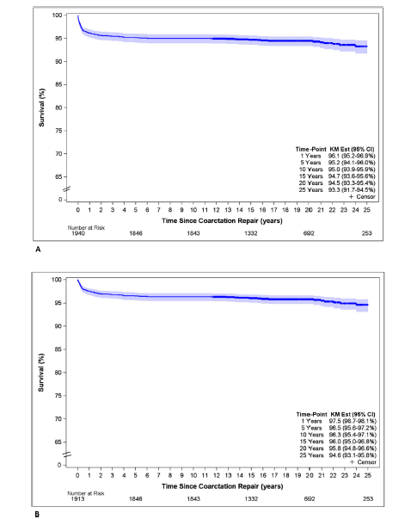

Figure 3
