Maternal biomarkers for fetal heart failure in fetuses with congenital heart defects or arrhythmias.
Miyoshi T, Hosoda H, Nakai M, Nishimura K, Miyazato M, Kangawa K, Ikeda T, Yoshimatsu J, Minamino N.
Am J Obstet Gynecol. 2019 Jan;220(1):104.e1-104.e15. doi: 10.1016/j.ajog.2018.09.024. Epub 2018 Sep 28.
PMID: 30273582

Take Home Points:
- Diagnosis of fetal heart failure is challenging and primarily depends on ultrasound findings such as the cardiovascular profile (CVP), which is routinely used in fetal echocardiography.
- Maternal serum concentrations of 3 cytokines: TNF-a, VEGF-D, and HBEGF-like GF, were associated with fetal heart failure.
- How this data may change management is yet unclear, but could potentially impact how we diagnose the severity of heart failure as well as determine the efficacy of fetal therapy.

Commentary from Dr. Jared Hershenson (Greater Washington DC), section editor of Fetal Cardiology Journal Watch: This interesting study out of Japan looked at a panel of inflammatory serum biomarkers to try to diagnose heart failure in a cohort of infants with congenital heart defects or arrhythmias. The goal was to try to find biomarkers that would cross the placenta and be detected via maternal blood work instead of percutaneous umbilical blood sampling. 50 singletons with either CHD or arrhythmias as diagnosed on fetal echocardiograms and 50 controls were followed. Maternal serum samples were collected and analyzed for 2 hormones and 36 cytokines using the Bio-Plex Pro Human Cancer Biomarker Panels 1 and 2 at 10-14 weeks, 28-33 weeks, and 34-39 weeks. Concurrent, usually biweekly, fetal echocardiograms were obtained to monitor arrhythmia status and CVP (see table 1), with a score of </= 7 defined as heart failure until 37 weeks gestation, when all patients were admitted to the hospital and followed at least weekly until delivery.

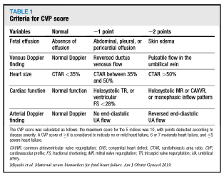

All controls had a CVP of 10. All other baseline perinatal characteristics were not significantly different between groups. Of 37 fetuses with CHD, 1 had tricuspid valve dysplasia and moderate TR, with a CVP of 7. 8/13 fetuses with an arrhythmia had a tachyarrhythmia (SVT/EAT/atrial flutter) that cardioverted with treatment. No fetus with complete heart block had a change in CVP over the remainder of gestation, regardless of fetal treatment (e.g. dexamethasone). A total of 5 of the arrhythmia patients had a CVP between 5-7 during the 28-33 week period and 3 (all with CHB) at 34-39 weeks. 2/3 had been diagnosed with CHB in the previous period (see Table 2).

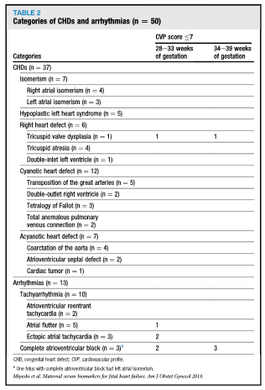

After testing for cytokine stability in the serum samples of volunteers, the maternal samples were compared between patients with (n=6) and without heart failure (n=61) at 28-33 weeks. The “without heart failure” group included 45 controls, 10 with CHD, and 6 with arrhythmias). Baseline perinatal characteristics and other lab data were similar between groups. A principal component analysis was done to determine which of the hormones and cytokines were most important (see Figure 2). Table 3 shows the 6 variables that showed a statistically significant difference, and table 4 shows the results of univariate and multivariate analysis. Cut-off values calculated using ROC analysis is shown in Table 5. Including TNF-a + VEGF-D + HB-EGF resulted in a 100% sensitivity and 80% specificity, with an NPV of 100.

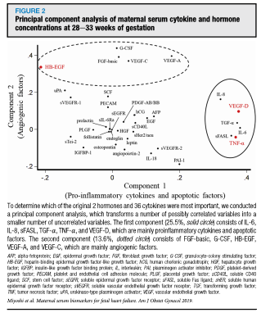

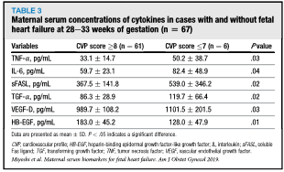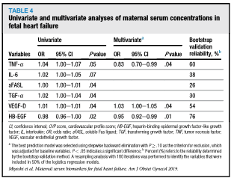
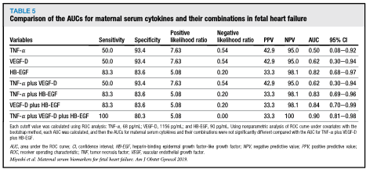

This study showed that 3 cytokines were associated with heart failure in fetuses. In those without heart failure (by CVP), all maternal serum levels were similar, regardless of the presence of CHD or treated arrhythmias. The authors speculate whether these cytokines are present due to fetal heart failure triggering a maternal inflammatory response to an inflamed placenta (mirror syndrome). Clear limitations to this study include the fact that only a specific set of cytokines/hormones were studied and the most severe cases were excluded as they were treated in many cases (or delivered prematurely). They also did not include the most common cause of fetal heart failure, placental insufficiency, so this could have a different biomarker pattern. Additionally, it is unclear whether this level of diagnostic testing can be more helpful than following CVP in terms of determining when to treat or deliver, or whether outcomes may be improved, but this was a very interesting first step towards hopefully other larger and more long-term studies in the future.

