Mechanism and Risk Factors for Death in Adults With Tetralogy of Fallot.
Egbe AC, Kothapalli S, Borlaug BA, Ammash NM, Najam M, Bajwa N, Tarek K, Matthew J, Connolly HM.
Am J Cardiol. 2019 Jun 7. pii: S0002-9149(19)30627-7. doi: 10.1016/j.amjcard.2019.05.048. [Epub ahead of print]
PMID: 31272701
Similar articles

Take Home Points:
- Annual event rate of death or cardiac transplant was 0.9 % in a Mayo Clinic cohort of 465 TOF patients.
- Six independent risk factors associated with death/transplant were age > 42 years, atrial fibrillation, ≥ moderate QRS fragmentation, LVEF < 50 %, RVEDP > 16 mmHg, and LVEDP > 16 mmHg.
- Nearly two-fold increased risk of death or transplant per unit increase in number of risk factors.

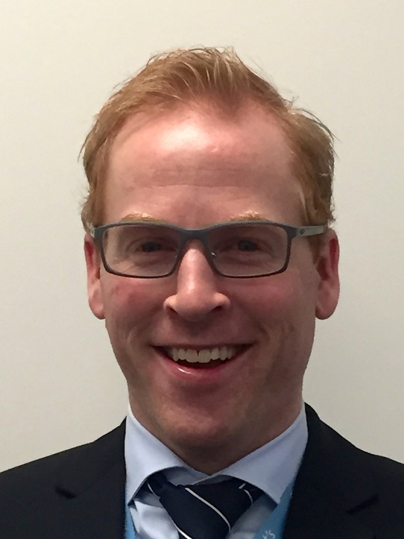
Commentary from Dr. Timothy Roberts (Melbourne, Australia), section editor of ACHD Journal Watch: The aim of this retrospective analysis from the Mayo Adult Congenital Heart Disease database of 465 adults with repaired TOF was to identify risk factors for death and/or cardiac transplantation.
Patients’ electronic medical records were interrogated to collate data of patient demographics, co-morbidities, medications, heart rhythm, echocardiograms, cardiopulmonary exercise testing, cardiac magnetic resonance imaging, and cardiac catheterization. Data from the first visit and test/procedure was used as the baseline variable. Full datasets were not available for all patients, with a single conditional imputation method used to correct for missing data in the multivariate analysis.

Baseline age was 37 ± 14 years, 48 % men, and mean age at time of TOF repair was 5 (3 – 10) years. A transannular patch repair was performed in 37 % of the cohort.
The endpoint of death and/or transplant occurred in 57 (12%) patients during a follow-up of 13.6 ± 8.2 years, giving an event rate of 0.9 % per year. Mean age at death (54/57 patients with combined endpoint) was 57 ± 15 years; key causes of death included:
- congestive cardiac failure 23 (43%)
- arrhythmic/sudden cardiac death in 14 (26%)
- malignancy in 5 (9%),
- sepsis/multisystem organ failure in 4 (7%)
- postoperative death following cardiac surgery in 3 (6%)

Three underwent cardiac transplantation at a mean age of 54 ± 5 years, with one dying 13 months later.
A multivariate risk model (Table 3, below), incorporating all statistically significant univariate correlates, identified the following risk factors:
- age >42 years (HR 1.86, 95% CI 1.24 to 2.03),
- atrial fibrillation (HR 1.84, 95% CI 1.06 to 3.17),
- ≥moderate QRS fragmentation (HR 1.92, 95% CI 1.47 to 2.81),
- left ventricular ejection fraction <50% (HR 1.39, 95% CI 1.08 to 2.31),
- right ventricular end-diastolic pressure >16 mm Hg (HR 1.41, 95% CI 1.02 to 1.22), and
- left ventricle end-diastolic pressure >16 mm Hg (HR 1.32, 95% CI 1.11 to 1.89).

Each independent risk factor was assigned one point; of the original 465 patients, 208 (45 %) had no risk factors (0 points), 191 (41 %) were low risk (1-2 points), 59 (13 %) were of intermediate risk (3-4 points), and 7 (1.5 %) were at highest risk (5 or 6 points). Using the patients without risk factors as the reference group, the annual event rate rose incrementally for each additional risk factor (no risk factors, 0.2 % per year; low risk group 1.0% per year; intermediate risk group 2.7% per year; and the high risk group 4.6% per year); see figure 1 (below).

A number of risk factors have previously been described in association with TOF and either all-cause death or sudden cardiac death; examples include the Khairy score which incorporates six risk factors (prior palliative shunt, inducible sustained ventricular tachycardia (VT) during electrophysiology study, QRS duration ≥180 msec, ventriculotomy incision, non-sustained VT, and left ventricular end-diastolic pressure (LVEDP) ≥12 mmHg), and the INDICATOR multi-centre study (right ventricular hypertrophy, right ventricular hypertension, left ventricular dysfunction, and atrial arrhythmia). Not exclusive to TOF, VO₂peak parameters have also been demonstrated to carry prognostic information in relation to all-cause mortality in ACHD. Interestingly, the current study only found elevated LVEDP to be an independent risk for death/transplant and not any other of the Khairy score parameters, while neither VO₂peak or VE/VCO₂ were associated with death or transplant. Contradictions in significant risk factors identified may reflect different population groups studied, and it should be noted that the current study did not have all invasive haemodynamic, exercise, or CMR data. Nonetheless, it offers a relatively straightforward framework of risk factors to consider in the broader TOF population which is less reliant on invasive measurements/procedures such as the Khairy score.

