Pathophysiologic and Prognostic Implications of Right Atrial Hypertension in Adults With Tetralogy of Fallot.
Egbe AC, Bonnichsen C, Reddy YNV, Anderson JH, Borlaug BA.
J Am Heart Assoc. 2019 Nov 19;8(22):e014148. doi: 10.1161/JAHA.119.014148. Epub 2019 Nov 8.
PMID: 31701796 Free Article
Similar articles
Select item 31742886

Take Home Points:
- Increasing RAP in symptomatic patient with TOF —an integrated measure of right heart compliance—was associated with worsening exercise capacity, disease severity and cardiovascular adverse events.
- RAP can be used for risk stratification in symptomatic TOF patients and can have potential clinical implications regarding type and timing of intervention.
- Furthermore, assessment of IVC size and collapsibility can be used for noninvasive estimation of RAP and correlated with event-free survival.

Commentary by Dr. Soha Romeih (Aswan), section editor of ACHD Journal Watch: Right ventricular (RV) systolic dysfunction frequently develops in adults with repaired TOF and is one of the criteria used to guide the decision for PVR. RV diastolic dysfunction typically precedes systolic dysfunction, suggesting that this might be an earlier indicator for ventricular dysfunction, but the assessment of RV diastolic function is challenging, and there are no validated noninvasive indices of RV diastolic function in the TOF population.
Increased RAP is a predictor of mortality in patients with heart failure due to acquired heart disease. It seems likely that TOF patients might have abnormal RA and RV mechanics caused by myocardial injury and remodeling because of prior surgical and ongoing hemodynamic insult, thus causing abnormal RAP.
Egbe et al, in the current study hypothesized that RAP, as assessed by the gold standard of invasive hemodynamic assessment, would be associated with disease severity and cardiovascular adverse events in adults with TOF.
Methods
This is a retrospective cohort study, and the target population is symptomatic patients with repaired TOF who underwent right heart catheterization at the Mayo Clinic Rochester (Minnesota) from 1990 till 2017. Patients with tricuspid valve prostheses were excluded.
The primary study objective was to determine the association between RAP and disease severity indices, assessed across 3 clinical domains:
(1) Aerobic capacity (percentage of predicted peak oxygen consumption [VO2])
(2) Arrhythmias, Atrial/ventricular arrhythmia - defined as documented atrial fibrillation, atrial flutter/tachycardia, or non-sustained ventricular tachycardia
(3) Heart failure hospitalization - defined as an admission for volume overload (pulmonary congestion and/or peripheral edema) requiring intravenous diuretics.
The secondary study objective was to determine the association between RAP and a. cardiovascular adverse events - defined as sustained ventricular tachycardia, resuscitated or aborted sudden cardiac death, heart transplantation, or b. all-cause mortality.
Exploratory analysis was performed to determine the correlation between RAP and echocardiographic indexes of RV diastolic function
- Tricuspid inflow early diastolic velocity/tricuspid inflow late diastolic velocity (E/A)
- Tricuspid inflow early diastolic velocity/tricuspid annular tissue Doppler early systolic velocity (E/e’),
- Tricuspid inflow deceleration time (DT)
- Inferior vena cava (IVC) size. IVC was defined as IVC >21 mm, and reduced collapsibility during inspiration was defined as <50% decrease in IVC diameter during inspiration.

Cardiac Cath
- Total pulmonary resistance = mean PAP/pulmonary blood flow index
- PA compliance index = the ratio of RV stroke volume index/PA pulse pressure
- Pulmonary elastance = the ratio of PA systolic pressure/stroke volume index.
- LV transmural pressure, which reflects the net distending pressure that favors LV filling, = PA wedge press minus RAP.

Echocardiography
Only echocardiograms performed within 7 days from the time of cardiac catheterization were analyzed for this study.
Outcomes Assessment
- All exercise tests were required to be performed within 6 months from the time of cardiac catheterization.
- Percentage of predicted peak VO2 was assessed using upright treadmill cardiopulmonary exercise testing, with maximum effort defined as respiratory quotient >1.1.
- Atrial/ventricular arrhythmia and heart failure hospitalization status were ascertained in 100% of patients as of December 31, 2017, using the date of the last clinic visit.
- All-cause mortality was ascertained using the Mayo Clinic registration database and Accurint, an institutionally approved location service, in 100% of patients as of December 31, 2017.
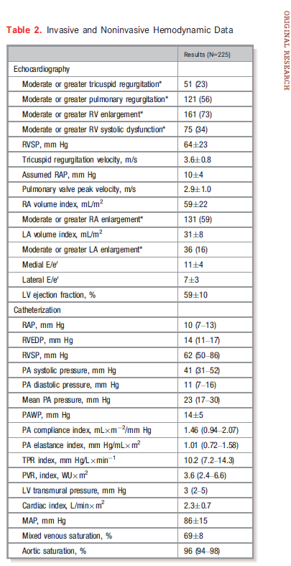
Results
Clinical and Hemodynamic Data
A total of 231 ambulatory patients with TOF underwent right heart catheterization within the study period. 6 were excluded because they had tricuspid valve prostheses.
RPA and hemodynamic cath:
Mean RAP was 10.7±5.2 mm Hg, and median RAP was 10 mm Hg. There was good correlation between RAP and RV afterload, as measured by PA compliance, PA elastance, and total pulmonary resistance (Figure 1), but no correlation between RAP and RV outflow tract (RVOT) obstruction, suggesting that the association between RAP and RV afterload is more likely due to pulmonary vascular dysfunction (both PA and capillaries) and left atrial hypertension. Similarly, RAP correlated with LV transmural pressure and cardiac output (Figure 1).
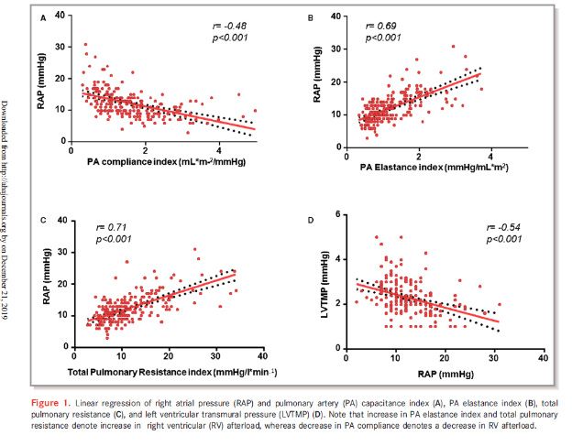
- RAP and Disease Severity Indexes

Of 225 patients, 95 (42%) experienced atrial/ventricular arrhythmias (63 with atrial fibrillation, 56 with atrial flutter/ tachycardia, and 50 with non-sustained ventricular tachycardia) during the follow-up period. RAP was associated with atrial/ventricular arrhythmia occurrence.

An exploratory analysis was performed to assess the correlation between RAP and ventricular arrhythmias. An association between RAP and ventricular arrhythmia occurrence were noted.
There were 26 patients (12%) with heart failure hospitalizations, and RAP was associated with heart failure hospitalization).
Of the 128 patients (57%) with exercise test data, the mean peak VO2 and percentage of predicted peak VO2 were 21±6 mL/kg per minute and 62±15%, respectively. There was an inverse correlation between RAP and percentage of predicted peak VO2 (Figure 2).

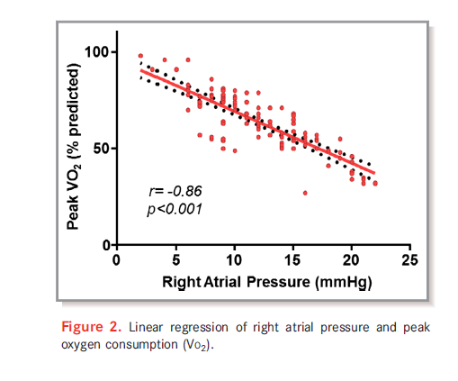
- RAP and Cardiovascular Adverse Events

Mean follow-up from the time of cardiac catheterization was 7.3±5.8 years, yielding total follow-up of 1642 patient-years. In total, 97 patients (43%) underwent PVR during follow-up. During this period, there were 28 cases of sustained ventricular tachycardia, 4 cases of aborted sudden cardiac death, 4 patients who underwent heart transplant, and 35 patients who died. The cause of death was end-stage heart failure (n=20), arrhythmic death (n=6), postoperative death after cardiac surgery (n=3), bleeding- or stroke-related death (n=1), malignancy (n=1), sepsis (n=1), and unknown (n=3).
A cardiovascular adverse event end point occurred in 55 patients (24%), yielding an event rate of 3.2 per 100 patient-years. The 10-year rate of freedom from cardiovascular adverse events was 74% for the entire cohort. RAP >10 mm Hg provided the best prediction of cardiovascular adverse events. Patients with RAP >10 mm Hg had lower event-free survival compared with those with RAP ≤10 mm Hg (Figure 3). RAP was a statistically significant predictor of cardiovascular adverse events

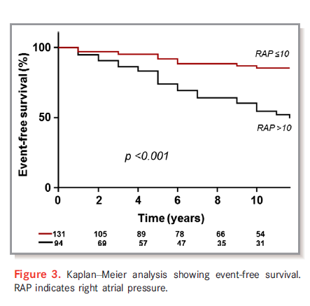

Echocardiographic Predictors of RAP
Of all diastolic function indexes assessed, IVC size and collapsibility provided the best detection of elevated RAP (RAP >10 mm Hg). Dilated IVC had the best sensitivity to detect elevated, whereas dilated IVC with reduced inspiratory collapse had the best specificity to detect elevated RAP

Discussion
- The current study showed significantly worse outcomes in patients with high RAP (RV diastolic dysfunction and/or RA dysfunction) despite having similar severity of RVOT lesion (pulmonary regurgitation and stenosis).
- These data suggest that RAP might be considered when deciding on timing of RVOT intervention in patients with borderline indications for intervention, especially when symptoms (exercise intolerance, arrhythmia, and heart failure) seem disproportionate to the severity of RVOT lesion.
- Furthermore, RAP may also be considered during sudden death risk stratification because of its correlation with occurrence of ventricular arrhythmia occurrence.

Limitations
The current study was based on a selected cohort of patients who underwent cardiac catheterization, and this approach may limit the generalizability of the results.
Although this study will not be appropriate for describing the prevalence of diastolic dysfunction, the clinical implications of RV diastolic dysfunction reported in this study are still pertinent when dealing with symptomatic patients.

