Results of the Fontan Udenafil Exercise Longitudinal (FUEL) Trial.
Goldberg DJ, Zak V, Goldstein BH, Schumacher KR, Rhodes J, Penny DJ, Petit CJ, Ginde S, Menon SC, Kim SH, Kim GB, Nowlen TT, DiMaria MV, Frischhertz BP, Wagner JB, McHugh KE, McCrindle BW, Shillingford AJ, Sabati AA, Yetman AT, John AS, Richmond ME, Files MD, Payne RM, Mackie AS, Davis CK, Shahanavaz S, Hill KD, Garg R, Jacobs JP, Hamstra MS, Woyciechowski S, Rathge KA, McBride MG, Frommelt PC, Russell MW, Urbina EM, Yeager JL, Pemberton VL, Stylianou MP, Pearson GD, Paridon SM; Pediatric Heart Network Investigators.
Circulation. 2019 Nov 17. doi: 10.1161/CIRCULATIONAHA.119.044352. [Epub ahead of print]
PMID: 31736357
Similar articles
Select item 31736331

Take Home Points:
- Six months treatment with long-acting PDE5-inhibitor Udenafil resulted in a small but non-significant increase in peak VO₂ (primary outcome) in adolescents with single ventricle congenital heart disease and Fontan circulation
- Small significant improvements of uncertain clinical significance were seen in a range of secondary outcome measures of submaximal exercise at the ventilatory anaerobic threshold
- Albeit an essentially negative study, this is an excellent large, prospective, double-blind, randomized, multi-centre, placebo-controlled study which offers invaluable information for clinicians treating people with Fontan circulation.

Commentary from Dr. Timothy Roberts (Melbourne), section editor of ACHD Journal Watch:

Background
In the Fontan circulation, pulmonary blood flow is dependent on low pulmonary vascular resistance to maintain sufficient single ventricle preload. Adolescents have reduced exercise capacity relative to healthy peers, and this difference is accentuated over time and associated with an increased rate of hospitalization and heart failure symptoms. Previous studies evaluating pulmonary vasodilator therapy have reported mixed results. The aim of the Fontan Udenafil Exercise Longitudinal (FUEL) study was to evaluate the effect of long-acting PDE5-inhibitor udenafil on exercise performance and a range of cardiovascular and functional outcomes in adolescents with Fontan circulation over a six-month period.
Methods
Patients aged between 12 and 18 years who had undergone Fontan palliation and were not prescribed a PDE5-inhibitor were eligible for enrollment. Exclusion criteria comprised severe ventricular dysfunction, severe atrioventricular valve regurgitation, and a previous VO₂peak less than 50 % predicted.
Enrolled participants were randomized in a 1:1 fashion to udenafil or placebo in a double-blind manner. Baseline investigations included measurement of brain-type natriuretic peptide (BNP), cardiopulmonary exercise testing (CPET), echocardiography, and assessment of peripheral vascular function using peripheral arterial tonometry (PAT). Maximal effort in the CPET (defined by respiratory exchange ratio > 1.1) was required prior to randomization and commencement of drug therapy.
The primary outcome was the between group change in oxygen consumption at peak exercise (VO₂). Secondary exercise outcomes included additional between group changes at maximal exertion and submaximal exercise (ventilatory anaerobic threshold). Secondary clinical outcomes were the between group differences in change in the echocardiographic-derived myocardial performance index (MPI), change in the PAT-derived measure of peripheral vascular function log-transformed reactive hyperemia index (lnRHI), and change in log-transformed serum BNP level.
The study was powered correctly using historical data for CPET outcomes and used appropriate statistical techniques for analysis.
Results
Patient demographics are summarized in table 1 (below). A total of 400 subjects were recruited, with male predominance and mean age 15.5 years.

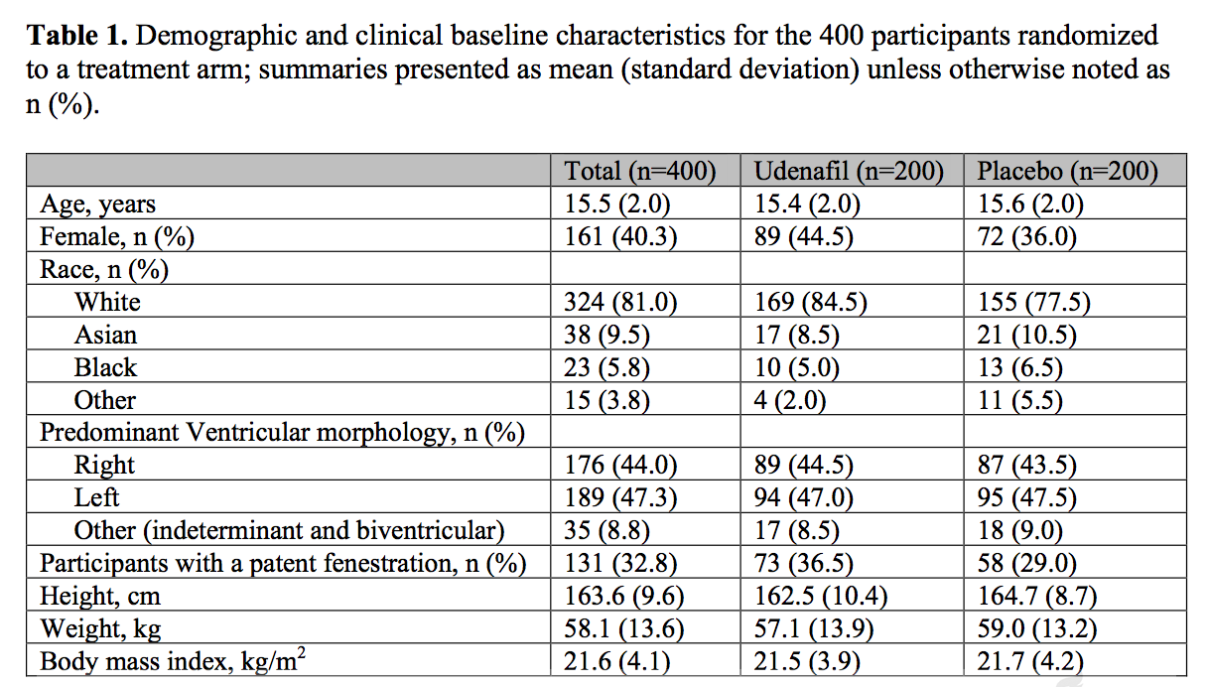

Resting, submaximal and peak exercise data are summarized in table 2 (below):

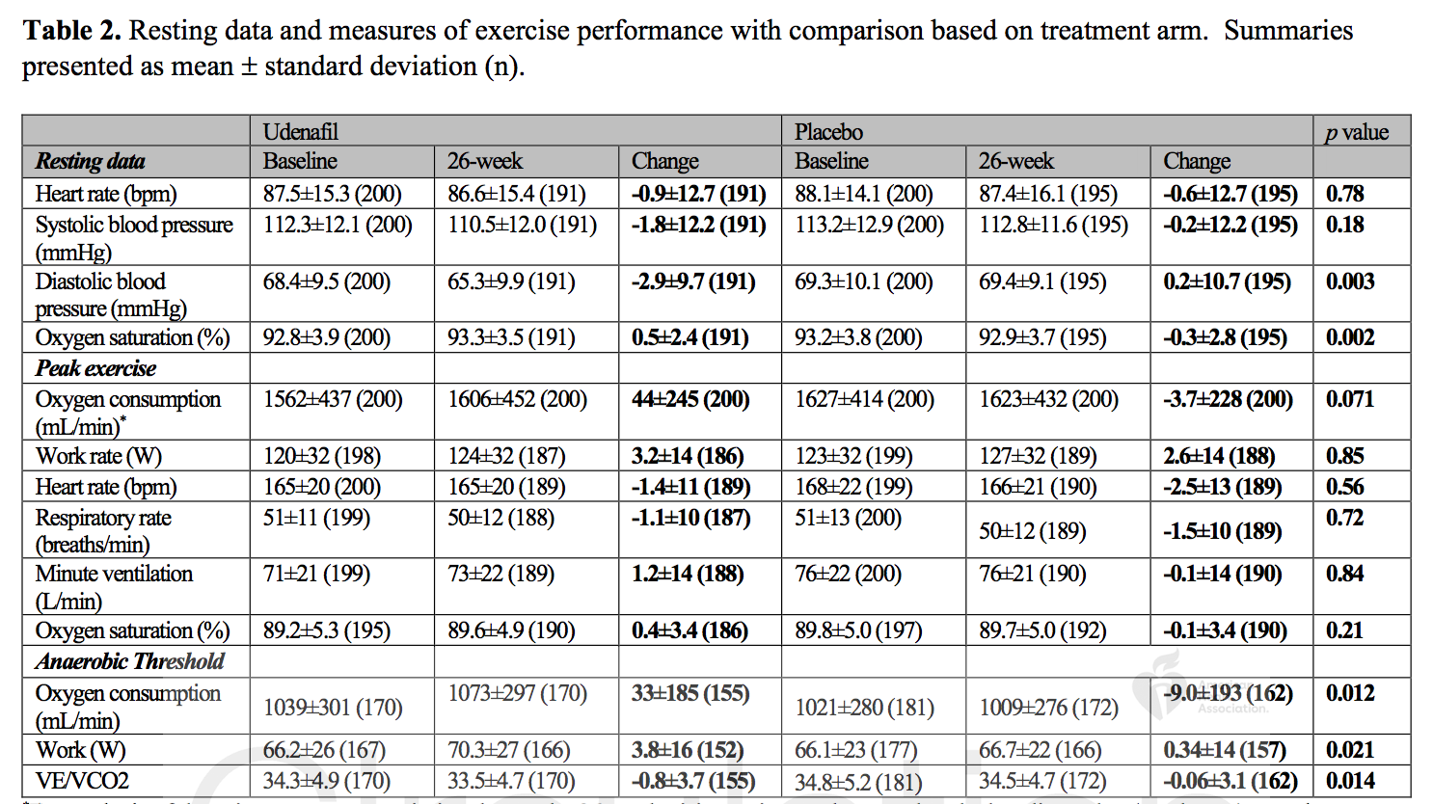

Peak VO₂ at maximal exertion increased 44 ml/min (2.8 %) in the udenafil group as compared to a marginal decline in the placebo cohort (-3.7 ml/min, -0.2 %) which did not reach statistical significance (P=0.071). VO₂ was able to be calculated at anaerobic threshold in 317 subjects; in this subset there was a statistically significant increase in VO₂ in the udenafil group (33 ml/min, 3.2 %) as compared to a reduction of 9 ml/min (-0.9 %) in the placebo group (P=0.012). Ventilatory efficiency (VE/VCO₂) improved marginally while work rate also improved in the udenafil group (+3.8 METS vs. +0.34 METS; P=0.021). There were no significant changes in secondary clinical endpoints.
Discussion
While the small increase in peak exercise VO₂ failed to reach statistical significance, the authorship group contend that peak VO₂ may not be as relevant an endpoint in the Fontan circulation and rather outcomes at submaximal exertion may be more sensitive to pharmacologic manipulation of the pulmonary vasculature. It is difficult to quantify the clinical relevance of the small improvements in submaximal exercise performance measurements, however this outstanding research may lead to further research opportunities assessing PDE5-inhibition and submaximal exercise performance within subpopulations of Fontan circulation patients.

