The Prognostic Value of Myocardial Deformation in Adult Patients With Corrected Tetralogy of Fallot.
van Grootel RWJ, van den Bosch AE, Baggen VJM, Menting ME, Baart SJ, Cuypers JAAE, Witsenburg M, Roos-Hesselink JW.
J Am Soc Echocardiogr. 2019 Jul;32(7):866-875.e2. doi: 10.1016/j.echo.2019.03.014. Epub 2019 May 4.
PMID: 31064677
Similar articles

Take Home Points:
- There is a clear role for strain analysis in adult patients with repaired ToF.
- Reduced myocardial deformation parameters, including RV longitudinal strain and LV apical rotation, are associated with worse outcomes in clinically stable patients with repaired ToF, independent of currently known markers.
- To enhance risk stratification, myocardial deformation imaging should be considered as an additional tool in routine clinical follow-up, but not to replace currently used strategies.
Commentary by Dr. Soha Romeih (Aswan, Egypt), section editor of ACHD Journal Watch:
van Grootel et al studied the myocardial deformation by echocardiography speckle-tracking analysis of both ventricles in asymptomatic adults with repaired ToF and its relationship with adverse outcome. This is a prospective observational study that included all clinically stable patients with repaired ToF, visiting the outpatient clinic between 2011 and 2013. Exclusion criteria were age < 18 years, pregnancy, and inability to understand and sign informed consent forms; patients were also excluded in case of poor echocardiographic image quality.
- Myocardial strain analysis included:
1- The left ventricle was assessed according to the 17-segment model as stated in the guidelines for echocardiographic chamber quantification. The rotation at the basal and apical levels of the left ventricle was measured by applying speckle-tracking after identifying the endo- and epicardial borders in the basal and apical short-axis views.
2- RV systolic function was assessed by measuring RV longitudinal strain (LS) of the free wall. The software describes clockwise rotation as a positive value and counterclockwise rotation as a negative value. The peak apical rotation and basal rotation during systole was assessed. Twist was calculated and defined as the maximum value of the simultaneous difference between apical rotation and basal rotation (apical minus basal rotation) during systole.
Strain measurements were blinded.
- Definition and assessment of events: The primary endpoint was a composite of death or heart failure. Heart failure was defined as requiring changes in HF medication or hospital admission. The secondary endpoint was a supraventricular or ventricular arrhythmia (symptomatic and recorded or treated), hospitalization for cardiac reasons, or reintervention (both surgical and percutaneous). End points were manually tracked on a yearly basis.
Results:
- In total, 179 patients were eligible in the original cohort. Of these, 28 (16%) were excluded because of poor echocardiographic image quality. Of the 151 patients included, the median age was 34.6 years [IQR, 27.9–44.9 years] and 65.1% were men. The control group of 88 subjects had a median age of 31.2 years (IQR, 25.3–41.9 years), and 48 (54.5%) were men.
- All patients had significantly lower myocardial deformation compared to controls (Figure 1)
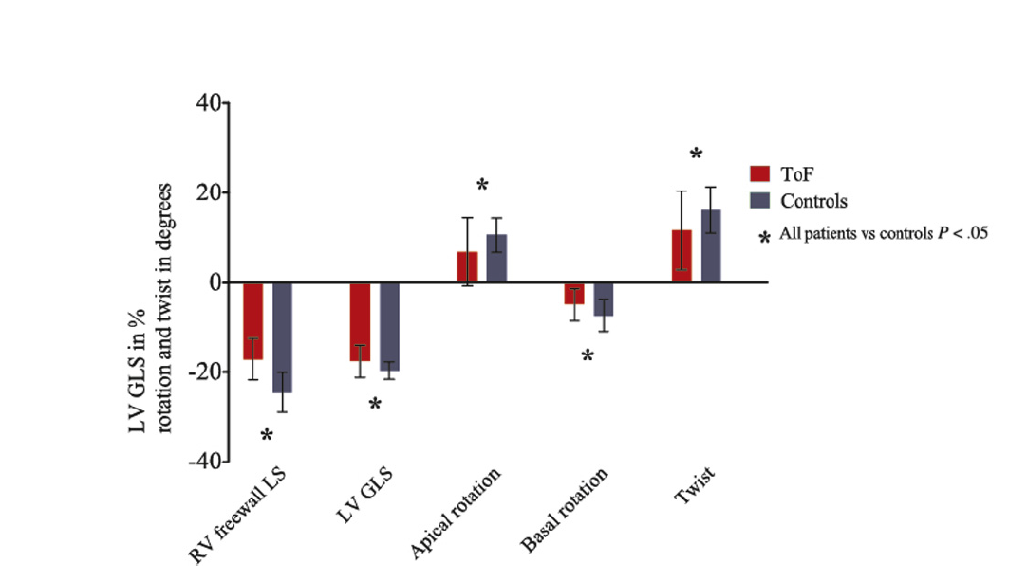

- The patients with decreased LV GLS had larger LV end-systolic dimensions and volumes and lower LVEFs. RV free wall strain was significantly lower in patients with reduced LV GLS. (ventricular-ventricular interaction) There were no differences in functional valvular status.

- The primary and secondary endpoints occurred in 14 (9.3%) and 62 (41.1%) patients, respectively. Baseline RV free wall LS and LV GLS were significantly associated with the primary endpoint and also with the secondary endpoint.

- Survival was significantly better in patients with higher strain values with regard to both the primary and secondary endpoints. (Figure 2)

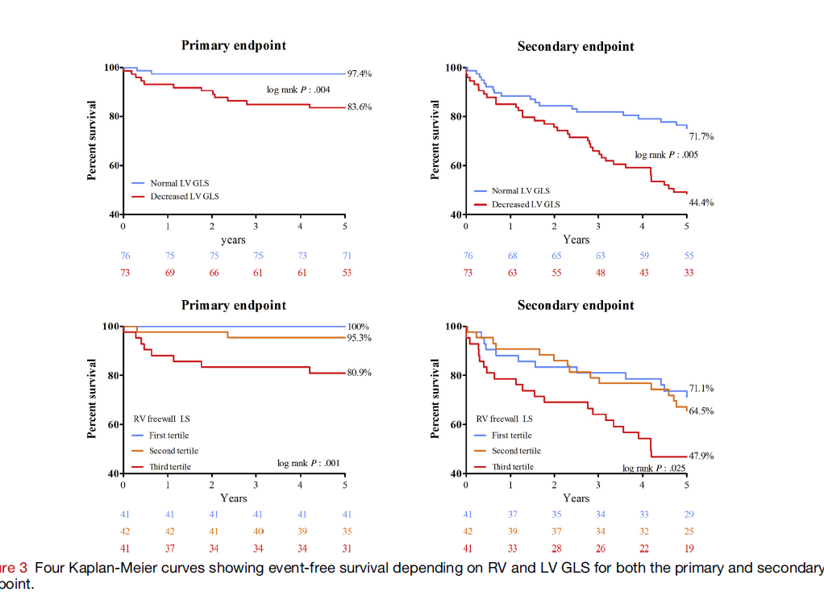

Conclusion:
This study shows that myocardial deformation is important in determining prognosis in patients with repaired ToF. Baseline longitudinal strain of either the left or right ventricle was significantly lower in patients who died or developed heart failure.
Strikingly, apical rotation and NYHA functional class II were the only variables that were independently associated with the secondary endpoint in the multivariate model after correction for several clinical and echocardiographic variables known to be associated with outcome.
Limitations:
As mentioned in the article being as single center study, may have led to inclusion bias and limited numbers. Moreover, comparing echocardiography myocardial deformation mentioned in the current study would be better compared with well-studied parameters from MRI as ventricular volumes and functions particularly for RV.

Also, though patients claim to be “asymptomatic” , many may lead a sedentary lifestyle - exercise capacity measured by exercise test parameters such as METS and VO2 max would therefore be of greater help to correlate with myocardial deformation.

