2019 updated consensus statement on the diagnosis and treatment of pediatric pulmonary hypertension: The European Pediatric Pulmonary Vascular Disease Network (EPPVDN), endorsed by AEPC, ESPR and ISHLT.
Hansmann G, Koestenberger M, Alastalo TP, Apitz C, Austin ED, Bonnet D, Budts W, D'Alto M, Gatzoulis MA, Hasan BS, Kozlik-Feldmann R, Kumar RK, Lammers AE, Latus H, Michel-Behnke I, Miera O, Morrell NW, Pieles G, Quandt D, Sallmon H, Schranz D, Tran-Lundmark K, Tulloh RMR, Warnecke G, Wåhlander H, Weber SC, Zartner P.
J Heart Lung Transplant. 2019 Sep;38(9):879-901. doi: 10.1016/j.healun.2019.06.022. Epub 2019 Jun 21.
PMID: 31495407
Similar articles
Select item 31324444

Take Home Points:
- Pulmonary hypertension mortality has been decreasing over the last 2 decades in children and adults, likely secondary to increased awareness, more accurate diagnoses, better risk stratification and early initiation of combination pharmacotherapy.
- The lower limit of normal mean pulmonary arterial pressure (mPAP) was decreased from 24 mmHg to 20 mmHg.
- A subgroup of children with idiopathic pulmonary arterial hypertension (IPAH) are positive responders to acute vasoreactivity testing (AVT) and would be classified as PAH long-term responders to calcium channel blockers (CCB).
- PAH and pulmonary veno-occlusive disease (PVOD)/pulmonary capillary hemangiomatosis (PCH) are now considered a spectrum of pulmonary vascular disease (PVD).
- Diagnostic methods and variables and their application to pediatric PH have been updated including echocardiography, cardiac MRI, CT and cardiac catheterization.
- New treatment algorithms, including medications for pediatric PH and PAH-CHD as well as drug-drug interactions are available.

Commentary from Dr. Charlotte Van Dorn (Rochester, MN), section editor of Pediatric Cardiology Journal Watch: This is an updated, comprehensive and practical guideline for healthcare providers providing care to children and young adults with pulmonary hypertension (PH) and pulmonary vascular disease (PVD). Methodology included an executive writing group consisting of 22 pediatricians, 7 adult congenital heart disease physicians, 1 adult pulmonologist and 1 thoracic surgeon. Specific features of this guideline include new patient groups such as PH associated with congenital heart disease (PAH-CHD), persistent PH of the newborn period (PPHN) as well as PH associated with bronchopulmonary dysplasia (BPD) or chronic lung disease (CLD). The guidelines also include new recommendations for the treatment of acute PH in the intensive care unit (ICU). This is also the first time the challenges of addressing PH in middle to low income regions are addressed. The following class of recommendation (COR) and level of evidence (LOE) grading were used in this guideline.
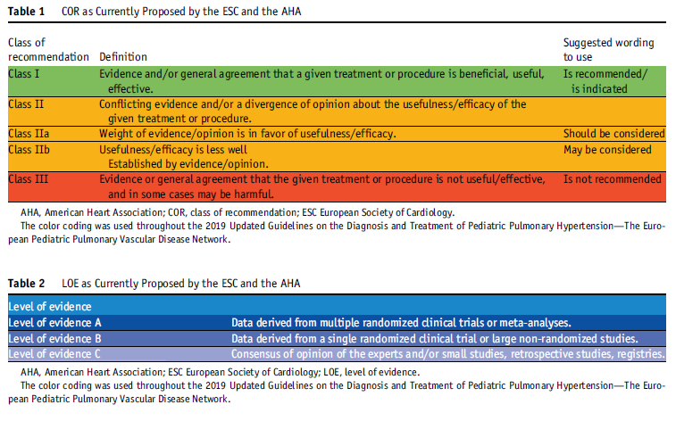

The most recent classification of PH according to the WSPH (Nice, 2018). The lower limit of normal mean pulmonary arterial pressure (mPAP) was decreased to 20 mmHg following a study demonstrating poor survival in adults with mildly elevated mPAP (20-24 mmHg).
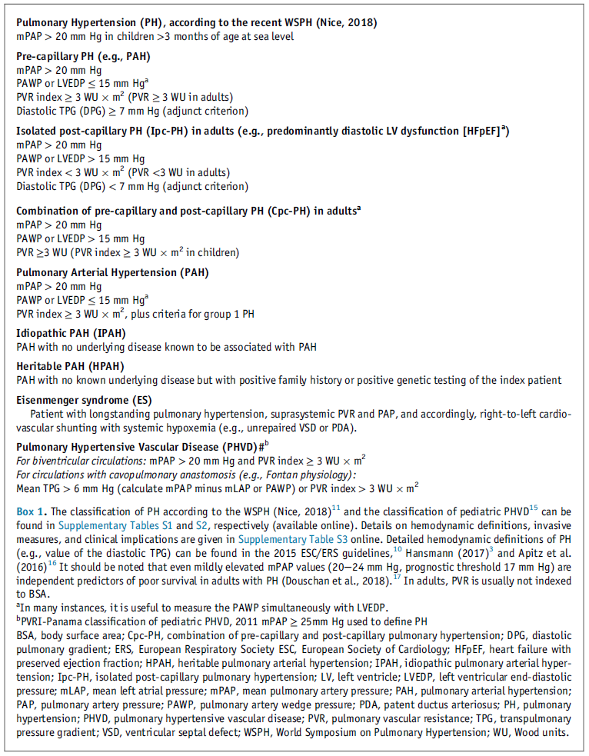
The diagnostic algorithm for a child or young adult with suspected PH.
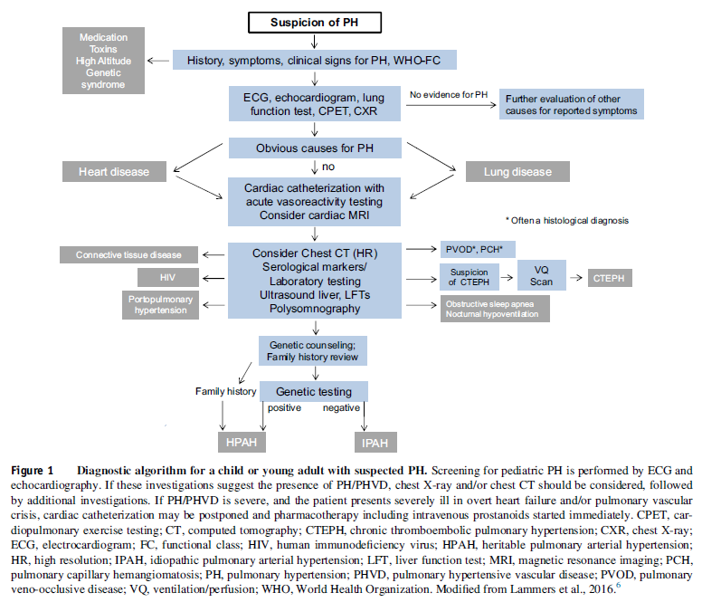

Treatment algorithm for pediatric PAH, including idiopathic and hereditary PAH (Figure 4 and Table 11). In acute care settings, treatment of acute PAH crises should include application of supplemental oxygen, minimization of aggravating factors (agitation, pain), treatment of triggering factors (acidosis, hypovolemia, anemia) and use of pharmacotherapy to increase myocardial perfusion, reduce right ventricular pressure afterload and counteract the right-to-left interventricular septal shift (Table 10).
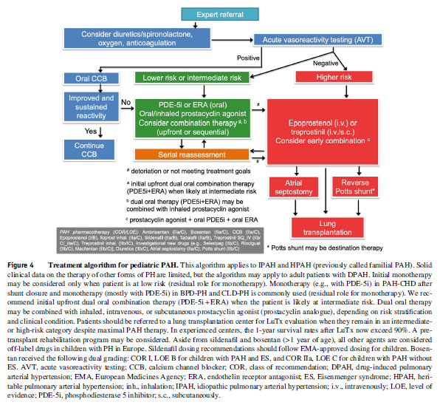
There are several findings to distinguish lower versus higher risk in pediatric PH and/or suspected pulmonary hypertensive vascular disease (PVHD); however, these only have a LOE C because of sparse pediatric data.
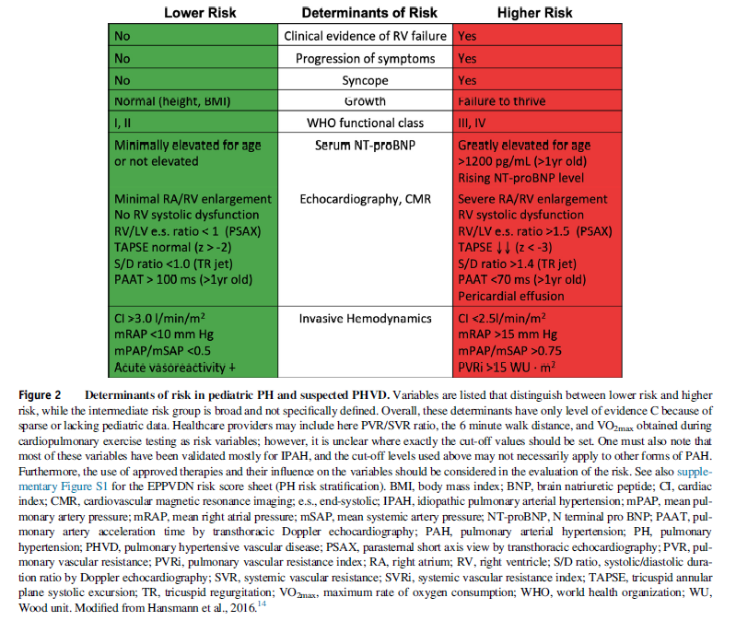
Algorithm for the management of patients with congenital shunt lesions associated with PAH or PHVD (Figure 3, Table 8).
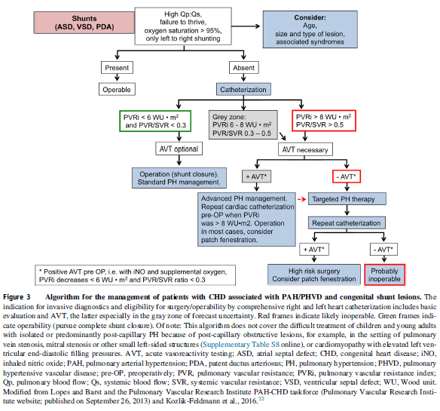
The diagnostics, monitoring (including transthoracic echocardiography, cardiac catheterization, cardiac magnetic resonance imaging, computed tomography), and genetic testing are summarized in Table 3-7.
The management of special PAH populations including children and adults with CHD as well as infants with persistent bronchopulmonary dysplasia or chronic lung disease are summarized in Tables 8 & 9.
The diagnosis and management of PH in middle and low income regions are summarized in Table 12.
