Mental health care for parents of babies with congenital heart disease during intensive care unit admission: Systematic review and statement of best practice.
Kasparian NA, Kan JM, Sood E, Wray J, Pincus HA, Newburger JW.
Early Hum Dev. 2019 Aug 24:104837. doi: 10.1016/j.earlhumdev.2019.104837. [Epub ahead of print]
PMID: 31455569

Take Home Points:
- Congenital heart disease is associated with psychological stress for mothers, fathers and their infants.
- In four of the five trials included, mental health interventions demonstrated some efficacy in reducing maternal anxiety. Mixed results were found for maternal depression and infant feeding.
- Mental health interventions for parents of infants admitted to the intensive care unit (ICU) did not improve quality of life, physical health or infant length of stay.
- An integrated approach is needed to address mental health issues in parents of infants with CHD admitted to the intensive care unit.

Commentary from Dr. Charlotte Van Dorn (Rochester, MN), section editor of Pediatric Cardiology Journal Watch: This is a systematic literature review and statement of best practice addressing mental health interventions and resources for parents of children born with congenital heart disease admitted to the intensive care unit (ICU). The objective of this review was to identify and critically appraise evidence on the efficacy and cost-effectiveness of mental health interventions delivered in the ICU as well as to develop guidelines for advancing health policy and practice.
There are many recognized psychologic and social stressors experienced by parents and infants within the ICU. Up to 30% of parents of infants with complex CHD experience symptoms consistent with post-traumatic stress disorder, another 25-50% experience depression or anxiety and up to 80% report severe psychological distress. Parents with higher distress report poorer physical health, high health service use, more suicidal ideation, and poorer quality of life.

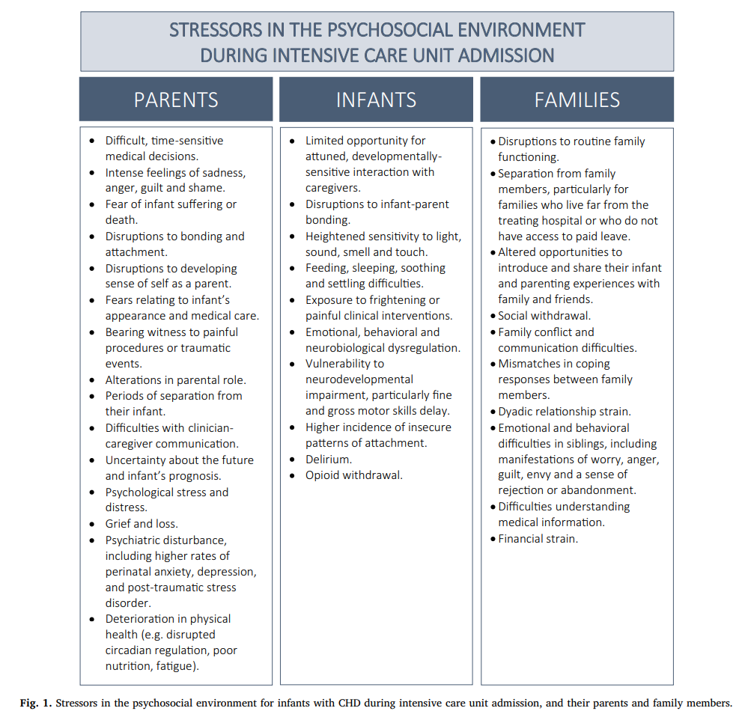

Methods included a search of 6 electronic databases. A total of 289 articles were identified but only 5 were included in this review.

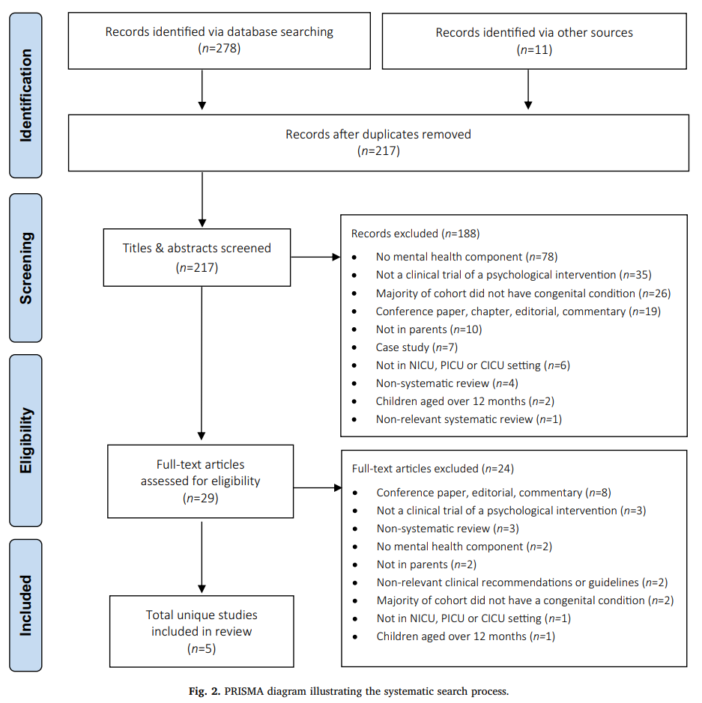

Results: A total of 339 participants (311 mothers, 28 fathers) were included. Interventions varied widely across the studies included. There was high risk of bias in the 3 non-randomized controlled trials.
Discussion: This systematic review of 289 articles resulted in a limited database for analysis and therefore should be approached with caution. Integrated psychotherapeutic interventions within the ICU environment are hypothesized to prevent or minimize severe psychosocial distress in parents of medically fragile infants. Four of the five identified trials demonstrated efficacy in reducing maternal anxiety; however, only a single trial demonstrated a positive effect of psychological intervention for parental depression. Further analysis of the 5 studies included in this review did demonstrate preliminary results showing positive effects of psychosocial interventions on maternal coping, mother-infant attachment, parenting confidence, family function, and communication. In this small review, there was no evidence for efficacy for family quality of life or intensive care unit length of stay. A single trial demonstrated some benefit for infant mental development at 6-months; however, this is difficult to generalize in a complex CHD population given the risks for neurodevelopmental abnormalities.
Limitations: There were multiple limitations to include in this systematic review including small sample size, single center recruitment, and lack of blinding. Some of the included studies relied on self-administered, symptom-based measures without reference to established cut-offs to provide indications of psychological change resulting in the risk for serious bias. There was also substantial variation in the interventions provided across groups.
Next steps: Mental health interventions are needed for parents of infants with CHD and should begin in the ICU. Structured psychosocial screening and a mental health assessment using validated tools is an important first step. This should be followed by an integrated and multidisciplinary approach to improve parental mental health care and therefore outcomes of this vulnerable population.

