Nakata index above 1500 mm2/m2 predicts death in absent pulmonary valve syndrome.
Karaca-Altintas Y, Laux D, Gouton M, Bensemlali M, Roussin R, Hörer J, Raisky O, Bonnet D.
Eur J Cardiothorac Surg. 2019 Jun 10. pii: ezz167. doi: 10.1093/ejcts/ezz167. [Epub ahead of print]
PMID: 31180449
Similar articles
Select item 31230936

Take Home Points:
- In absent pulmonary valve syndrome (APVS), a Nakata index (NI) of > 1500 mm2/m2 is a risk factor for death, even after pulmonary artery (PA) plasty.
- Whether repair at an earlier age (e.g. lower NI) would affect outcome remains to be seen, but this study does provide some prognostic and clinical information that could help providers counsel families and provide good post-operative care.

Commentary from Dr. Jared Hershenson (Greater Washington DC), section editor of Pediatric Cardiology Journal Watch: APVS, a rare congenital abnormality often associated with an outlet VSD and overriding aorta (e.g. Tetralogy of Fallot with absent pulmonary valve), is typically characterized by massive dilation of the pulmonary arteries. Respiratory symptoms can develop due to tracheal and bronchial compression, with the clinical presentation often dependent on the severity of those symptoms. High morbidity and mortality is present in neonates with symptoms soon after birth, but others can have more mild symptoms, with surgery being delayed for a few months until elective repair is undertaken. The study aims were to report clinical and surgical outcomes of patients with APVS, investigate predictors of mortality and prolonged postoperative ventilation, to find a threshold PA size predictive of negative outcomes, and to evaluate if PA plasty or the LeCompte maneuver would influence airway relief.
There were 3 groups: neonates < 28 days at repair, infants 28 days to 1 year old, children > 1 year old. Preoperative airway compression was evaluated with chest x-rays or CT scan and bronchoscopy when available, and graded as mild, moderate or severe. PA size was evaluated by echo and the Nakata index (sum of cross-sectional area of the left and right PAs in mm² divided by BSA). Figure 1 shows the flowchart for surgical technique used. Prolonged mechanical ventilation (PMV) was defined as > 7 days. There were 68 total patients with a median age at repair of 3.9 months and weight of 5 kg. Airway compression was more frequent at a younger age and more severe in the neonatal group as would be expected. Median NI was 938 mm²/m², and those that had surgery at a younger age, had pre- or postoperative airway compression, or required PMV had a significantly higher NI (see figure 2).

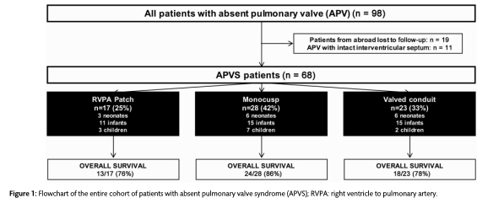

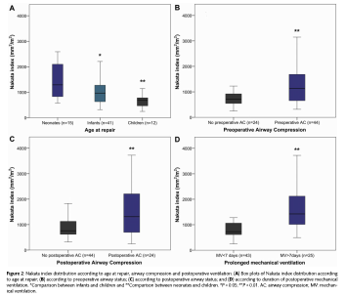

The mortality rate at discharge was 12% and overall was 19%, with most early and late deaths due to respiratory failure. Table 2 lists the preoperative univariate and multivariable risk factors for mortality, with only the NI and basal SpO2 % being significant. Figure 3 shows the ROC curves of the ability of the NI to predict outcomes. The AUC was 0.92. A cut off of 1500 mm²/m² had a sensitivity of 98% and a specificity of 82%. Figure 4 shows the Kaplan Meier survival curves according to NI.

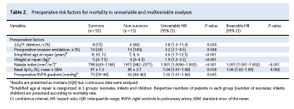
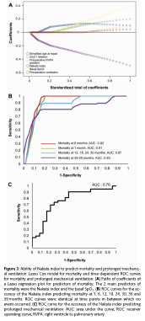
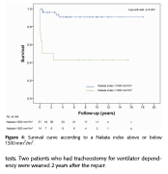

The median duration of ventilation was 15 days and only lower weight at repair was a risk factor in multivariable analysis for PMV. The accuracy of the NI for PMV was not as good as for survival (AUC 0.76). Patients with a PA plasty +/- LeCompte had an increased risk of death and neither had an effect on duration of ventilation. The NI for this subgroup remained the only risk factor for mortality, but the sensitivity/specificity of a cut-off of 1637 mm²/m² for those with a LeCompte was not as high (75% and 80% respectively).
As the authors note, PA dilation can not only cause external compression of major airways, but can also be associated with intrinsic abnormal lung function due to distal bronchial compression. Increased small airway resistance has been shown in this population, even higher than those with RSV. This may be a reason why a PA plasty and LeCompte did not show significant benefit, as it only helped the more proximal airway compression. A limitation of this study was the use of echo to calculate the NI in 40% of the cohort, as most centers use CT or MRI for this. This may affect the NI cut-off for prognosis. Additionally, given the small overall sample size, it may be difficult to fully extrapolate the results.

