CMR feature tracking left ventricular strain-rate predicts ventricular tachyarrhythmia, but not deterioration of ventricular function in patients with repaired tetralogy of Fallot.
Hagdorn QAJ, Vos JDL, Beurskens NEG, Gorter TM, Meyer SL, van Melle JP, Berger RMF, Willems TP.
Int J Cardiol. 2019 Aug 1. pii: S0167-5273(19)30911-8. doi: 10.1016/j.ijcard.2019.07.097. [Epub ahead of print]
PMID: 31402156 Free Article
Similar articles
Select item 31161492

Take Home Points:
- CMR-feature tracking derived measures of myocardial deformation are valuable for the prediction of VT or deterioration of ventricular function in patients with repaired TOF.
- LV systolic and diastolic circumferential strain-rate are identified as strong predictors of VT, of which LV systolic circumferential strain-rate was an independent predictor.
- No association between strain and strain-rate parameters and deterioration of ventricular function.

Commentary from Dr. Soha Romeih (Aswan, Egypt), section editor of ACHD Journal Watch:
TOF is one of the most common CHD, with excellent survival into adulthood when surgical repair is performed early in childhood. However, progressive RV dysfunction, due to residual pulmonary incompetence, and LV dysfunction are believed to from a substrate for electrical instability, resulting in both atrial and ventricular tachyarrhythmias.
Ventricular strain is a measure of relative deformation in a certain direction, with the unit percentage. In contrast, strain-rate measures the rate of this deformation, and therefore provides conceptually different information regarding myocardial performance. Furthermore, strain rate can be measured during both contraction phase and relaxation phase, providing information on systolic and diastolic function. The predictive value of CMR derived strain-rate parameters has not been reported previously in patients with repaired TOF. Thus, it remains unknown whether the conceptual differences between strain and strain-rate translate into different prognostic potential.
The aim of this study was to investigate the value of both CMR-feature tracking derived strain and strain-rate as predictors for VT, and additionally as a predictor for deterioration of ventricular function on CMR in patients with repaired TOF.
Patients with repaired TOF who underwent CMR investigation were included. Strain and strain-rate of both ventricles were assessed using CMR feature tracking.
The primary outcome was a composite of the occurrence of sustained VT or non-sustained VT requiring invasive therapy. The secondary outcome was analyzed in patients that underwent a second CMR after 1.5 to 3.5 years. Deterioration was defined as reduction (≥10%) in right ventricular (RV) ejection fraction, reduction (≥10%) in left ventricular (LV) ejection fraction or increase (≥30mL/m2) in indexed RV end-diastolic volume compared to baseline.

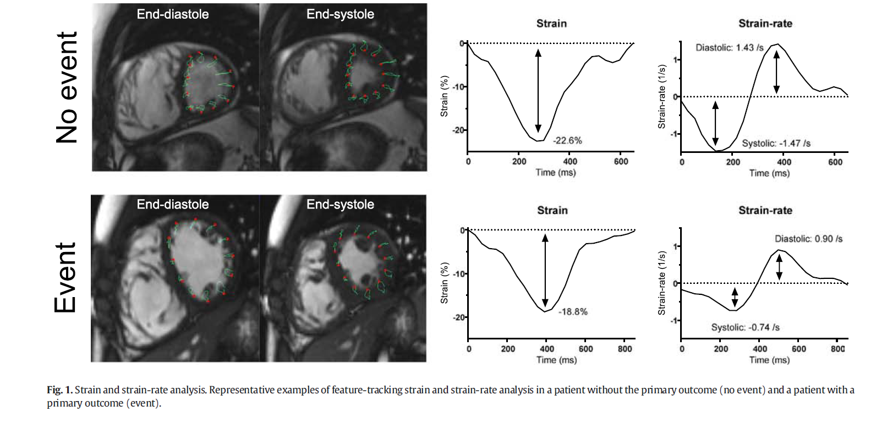

In total, 172 patients were included in this study, with a median age at the time of CMR examination of 24.3 years (interquartile range (IQR)15.9–35.4). Due to significant artifacts, 11 patients were excluded.
Of the included patients, 54 patients (31%) were pediatric (>18 years). Mass and volume measurements could be performed in 169 patients(98%), pulmonary flow measurements could be performed in 166 patients (97%), and strain measurements could be performed in 166 patients (97%). Within the predefined timeframe, a baseline echocardiographic examination was available for 143 patients (83%), and a baseline ECG examination was available for 162 patients (94%).

- Primary endpoint: Ventricular tachyarrhythmias

9 patients (4.5%) experienced the primary outcome. Univariate Cox-regression analysis showed no significant associations between RV-strain variables and primary outcome. However, a significant association of both systolic and diastolic LV circumferential strain-rate with primary outcome was demonstrated.

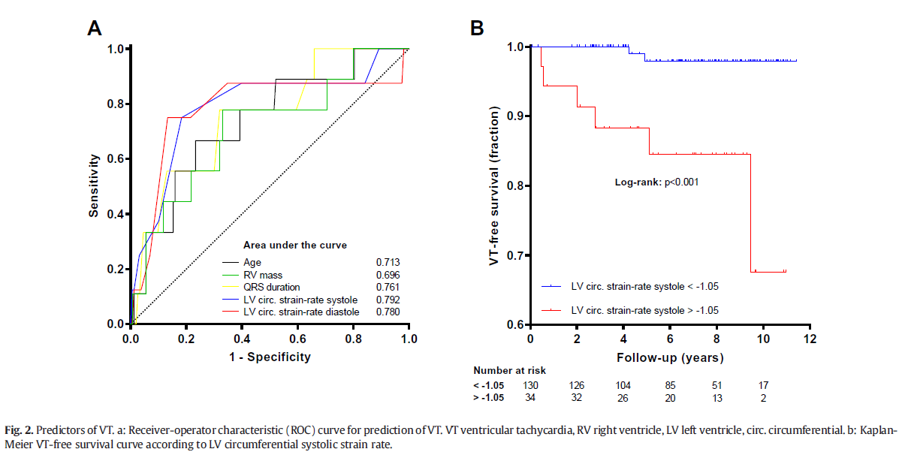

- Secondary endpoint: ventricular deterioration

70 patients were included for secondary endpoint analysis. Of these, 14 patients were classified as deteriorated and 56 as not deteriorated. At baseline, RV EDVi and RV mass index were significantly different between the deteriorated and not-deteriorated group (145.7 ± 29.3 vs. 121.1 ± 32.4 mL/m2, p = 0.012 and 47.0 ± 8.1 vs.41.5 ± 9.3 g/m2, p = 0.048 respectively).
Using logistic regression, only RV EDVi at baseline appeared significantly associated with deterioration (p = 0.018, odds ratio 1.26, 95% CI 1.04–1.51 per 10 mL/m2 increase) whereas for RV mass index, there was a borderline significant association (p=0.055, odds ratio 1.37, 95% CI 1.00–1.88 per 5 g/m2 increase). None of the strain or strain-rate variables were associated with deterioration.

Conclusion:
The present study shows that systolic LV circumferential strain-rate is a strong predictor for the primary endpoint of VT, independent of conventional variables in a population of both children and adults with repaired TOF.
Furthermore, RV EDVi was associated with deterioration of ventricular function. On the contrary, no association could be demonstrated between strain and strain-rate parameters and deterioration of ventricular function.
As surveillance for potentially life-threatening arrhythmias and ventricular deterioration is key in the long-term clinical follow-up of repaired TOF, the current study suggests that strain-rate parameters may improve risk stratification in these patients.

