Creatinine versus cystatin C to estimate glomerular filtration rate in adults with congenital heart disease: Results of the Boston Adult Congenital Heart Disease Biobank.
Opotowsky AR, Carazo M, Singh MN, Dimopoulos K, Cardona-Estrada DA, Elantably A, Waikar SS, McCausland FR, Veldtman G, Grewal J, Gray C, Loukas BN, Rajpal S.
Am Heart J. 2019 Aug;214:142-155. doi: 10.1016/j.ahj.2019.04.018. Epub 2019 May 22.
PMID: 31203159
Similar articles
Select item 31204032

Take Home Points:
- Chronic kidney disease, defined by reduced estimated glomerular filtration rate (eGFR), is associated with worse prognosis, and is common among adults with congenital heart disease compared to similarly aged peers
- eGFR calculations using creatinine can be inaccurate when actual muscle mass differs from expected population-based norms, as is seen in some adult CHD subjects – especially the single-ventricle Fontan population
- In a heterogenous cohort of 911 adults with CHD, cystatin C-based eGFR (CKD-EPI_{CysC}) classified a larger proportion of patients as having moderate or severely reduced eGFR as compared to creatinine-based eGFR (CKD-EPI_{Cr})
- CKD-EPI_{Cr} tended to overestimate eGFR in the low to mid-range and underestimate eGFR at the higher end of the range, compared with CKD-EPI_{CysC}
- Cystatin C-based eGFR better predicted all-cause mortality, and the composite of death or non-elective cardiovascular hospitalization.
- In the single-ventricle Fontan circulation subset there was poor agreement between creatinine-based and cystatin C-based eGFR.
- Measurement of cystatin C to better estimate eGFR should be considered in those with mildly reduced eGFR, and single-ventricle Fontan circulation patients.

Commentary from Dr. Timothy Roberts (Melbourne), section editor of ACHD Journal Watch:
The aim of this study was (1) to determine the correlation and agreement between various eGFR equations and (2) to compare the prognostic value of creatinine and cystatin C-based eGFR equations.
The primary outcomes of interest were (1) all-cause mortality and (2) a composite outcome of either all-cause mortality or non-elective cardiovascular hospitalization.
Adult patients were recruited from Boston Children’s or Brigham and Women’s Hospitals between 2012 – 2017. Patients were classified into different CHD pathophysiologic groups, New York Heart Association (NYHA) functional class, presence of cyanosis, diagnosis severity, and the presence of a single-ventricle versus biventricular circulation. Average age was 38.6 +/- 13.6 years, and 49.2 % were female. The majority (78.3 %) of subjects had moderate or severe complexity of CHD. The most common underlying diagnoses were:
- left-sided obstructive lesions (n=200, 22.0%),
- tetralogy of Fallot (n=187, 20.5%),
- single-ventricle physiology with a Fontan palliation (n=131, 14.4%),
- simple shunt lesion without clinical sequelae (n=122, 13.4%), and
- transposition of the great arteries with a systemic right ventricle (n=84, 9.2%).
Hypertension was present in 144 (14.6%) and diabetes in 38 (4.6%) patients.
The prevalence of chronic kidney disease according to eGFR is shown below in Figure 1 using various equations:

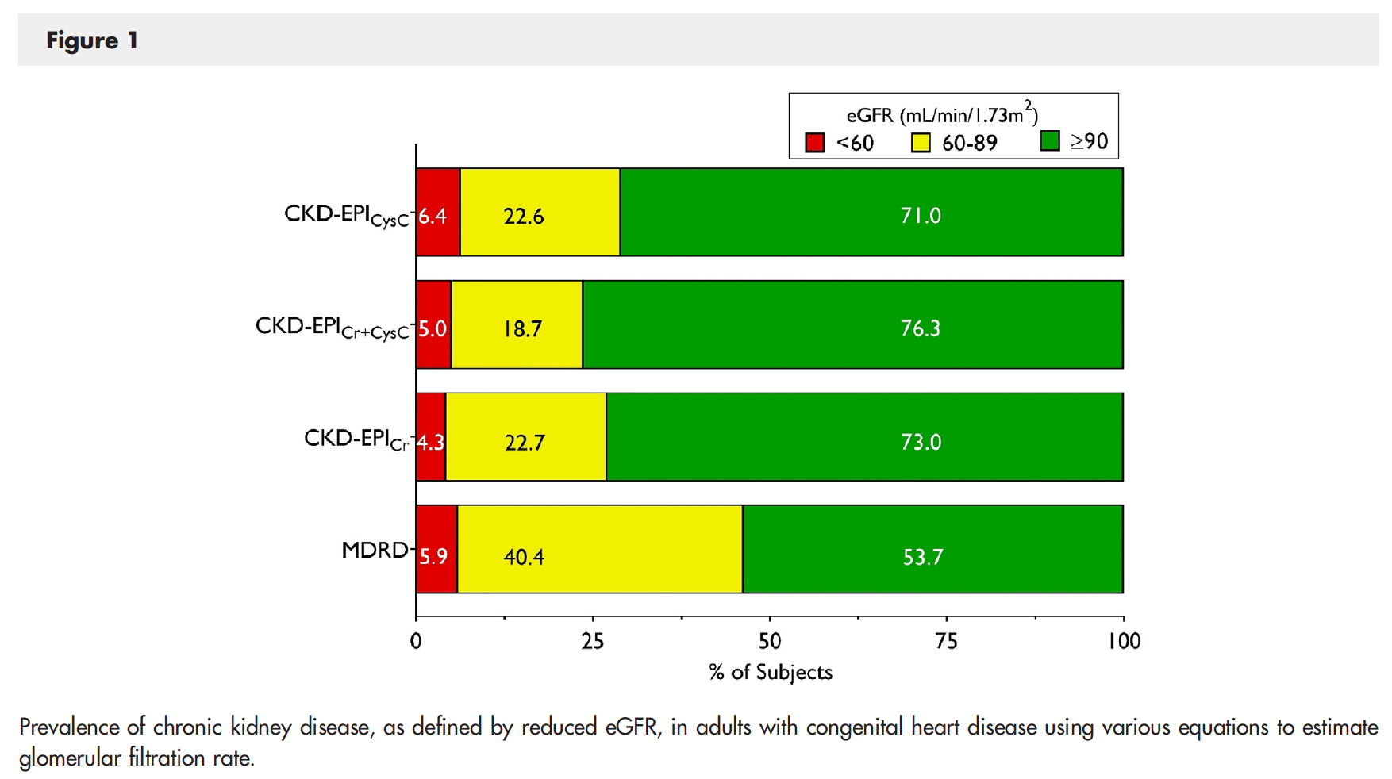

GFR category was classified differently in 228 of the 911 patients by the CKD-EPI_{Cr} and CKD-EPI_{CysC} equations. For both CKD-EPI equations, lower eGFR was associated with older age, higher BMI, hypertension, diabetes, atrial arrhythmias, pulmonary hypertension, cyanosis, and functional class. Average eGFR was similar for both CKD-EPI methods, however there was heterogeneity between different types of CHD. In particular, in the 131 patients with a single-ventricle Fontan circulation, creatinine-based eGFR was, on average, 10.3 +/- 19.3 higher with 95 % limits of agreement -28.2 to +48.8 ml/min/1.73 m². For both single-ventricle Fontan and biventricular circulations, CKD-EPI_{Cr} tended to overestimate eGFR in the low to mid-range and underestimate eGFR at the higher end of the range, compared with CKD-EPI_{CysC}.
In univariate analysis, there was a higher risk for both all-cause mortality and the composite outcome for patients categorized in the lowest eGFR category for all eGFR equations. There was a clear stepwise increase in risk for adverse outcomes across the 3 eGFR categories for CKD-EPI_{CysC} (figure 4, below). Multivariate adjustment was not performed for all-cause mortality due to low event numbers (n=34, 3.1%); however, for the composite outcome, only the CKD-EPI_{CysC} eGFR category remained a significant predictor on multivariate analysis. In the single-ventricle Fontan circulation cohort, higher CKD-EPI_{CysC} eGFR was associated with lower risk of the composite outcome (41 events in 131 patients; HR = 0.85 [0.76-0.95], P=0.005, C-statistic 0.652) whereas neither of the purely creatinine-based eGFR methods was significantly associated with the risk of the composite outcome.

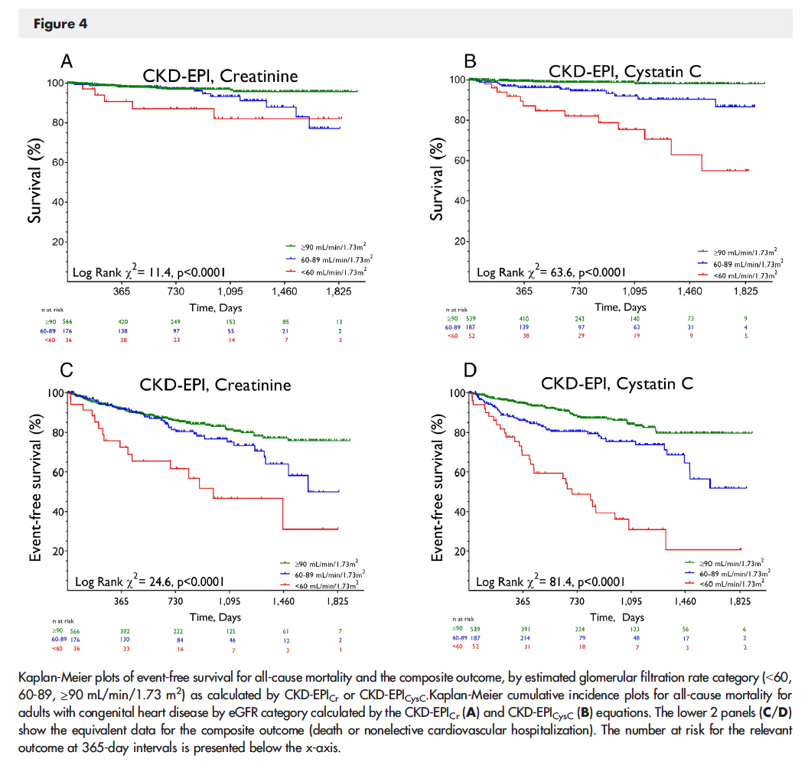

The authors conclude that more accurate identification of renal dysfunction could enable earlier intervention targeted at mechanisms of kidney disease, more appropriate drug dosing for renally cleared cardiovascular medications, assessment of risk when using iodinated contrast media for CT and catheterization, identification of patients at highest risk for acute kidney injury after surgery involving cardiopulmonary bypass, and more informed consideration during heart transplant evaluation.
It should be noted that cystatin C levels can be affected by other variables which were not assessed in the current study. Only a single measurement was considered, without factoring in the time since surgery nor changes on repeated measurements. The cost-benefit balance of measuring cystatin C is also unclear. Nonetheless, the study ultimately raises concern for the reliance on creatinine-based eGFR calculations, especially for single-ventricle Fontan circulation patients.

