Early and Late Effects of Cardiac Resynchronization Therapy in Adult Congenital Heart Disease.
Yanrong Yin, MD¹; Konstantinos Dimopoulos, MD, PhD²; Eriko Shimada, MD³; Karen Lascelles, PGDip²; Samuel Griffiths, MSc²; Tom Wong, MD, PhD²; Michael A. Gatzoulis, MD, PhD²; Sonya V. Babu‐Narayan, MBBS, BSc, PhD²; Wei Li, MD, PhD^{*,2}
J Am Heart Assoc. 2019 Dec 17;8(24):e014507. doi: 10.1161/JAHA.119.014507. Epub 2019 Dec 10. No abstract available.
PMID: 31818210 Free Article
Similar articles
Select item 31842676

Take Home Points:
- Heart failure and systemic ventricular dysfunction are a growing problem in older ACHD patients
- Cardiac Resynchronization Therapy (CRT) was effective in improving NYHA Class in 1-2 (Early) and 4-5 years (Late) after CRT placement in ACHD patients
- CRT was effective in improving systemic left ventricular function 1-2 years and 4-5 years after CRT placement in ACHD patients
- CRT was not effective in improving systemic right ventricular function 1-2 years and 4-5 years after CRT placement in ACHD patients
- QRS duration was the only predictor of CRT response though systemic LV morphology appears to important as well.
- CRT implantation can be achieved in biventricular circulation but does carry a high rate of device implant complications (20%).
- CRT should be considered in patients who meet criteria from the 2014 PACES/HRS Expert Consensus Statement on the Recognition and Management of Arrhythmias in Adult Congenital Heart Disease.

Comment from Dr. Akash Patel (San Francisco), section editor of Congenital Electrophysiology Journal Watch. As congenital heart disease patients continue to survive into older adulthood, the population of patients at risk for developing heart failure will continue to increase. The use of cardiac resynchronization therapy (CRT) for the treatment of heart failure in adults with congenital heart disease (ACHD) is poorly understood due to the limited number of patients, heterogeneity of congenital heart disease lesions, morphology of the systemic failing ventricle (right vs. left), impact of single ventricle vs. biventricular circulation, and short duration of follow-up. This study aimed to assess the impact of early and late effects of CRT in ACHD.
This was a retrospective single center study of all patients with ACHD who had reduced systemic ventricular function (LV Ejection Fraction (LVEF) < 40% or RV Fractional Area Change (RV FAC) < 35%), received CRT between 2004 and 2017, and had >90% biventricular pacing. The clinical practice for determining who underwent CRT placement during this time period was made on an individual basis through a multidisciplinary team approach (ACHD Cardiologist, Electrophysiologist, and Congenital Surgeon). After implantation, optimization of device programming was based on routine clinical practice. Baseline clinical, device, electrocardiographic, and echocardiographic data were obtained. Follow-up data was obtained during two time periods: early (1-2 years after CRT) and late (4-5 years after CRT). Outcome measures included death, heart transplantation, and positive response to CRT defined as a ≥ 5% absolute increase in LVEF or RVFAC at follow-up.
The study group included 54 patients who had reduced systemic ventricular function, a CRT device implanted with BiV pacing >90%, and acceptable imaging. The majority of patients had systemic left ventricles (72%). The lesions included were LVOT lesions (31%), ccTGA (24%), TOF (20%), others systemic LV (20%), and other systemic RV (4%). See figure below.

The mean age of the cohort was 46 ± 13 years with 74% male and a mean follow-up of 5.7± 3.0 years after CRT. 96% had NYHA Class II-IV heart failure. Baseline demographic in Table below.
Demographic and clinical characteristics
Age at CRT implantation (Years) | 46 ± 13
Men | 40 (74%)
Follow-up duration | 5.7 ± 3.0
SBP at CRT implantation, mmHg | 112 ± 15
DBP at CRT implantation, mmHg | 70 ± 10
BMI, kg/m2 | 25.7 (22.9–29.7)
Biochemical parameters
Urea, mmol/L | 7.1 (5.2–7.9)
Creatinine, Imol/L | 84 (76–94)
NYHA functional class
I | 3 (6%)
II | 20 (37%)
III | 28 (51%)
IV | 3 (6%)
Drug treatment
ACEI or ARB | 52 (96%)
Beta-Blocker | 48 (89%)
Aldosterone antagonist | 35 (65%)
Loop diuretic | 28 (52%)
Amiodarone | 11 (20%)
Anticoagulation | 36 (67%)
Digoxin | 5 (9%)

The majority of patients were in sinus rhythm (81%) with the remainder in permanent atrial fibrillation which effected pacing modality (VVIR/DDIR in 15%). As expected, the majority of ACHD patients had a non-LBBB QRS morphology (72%). See table below.

ECG
Sinus rhythm | 44 (81%)
Atrial fibrillation | 10 (19%)
QRS duration, ms | 174 ± 27
QRS morphological characteristics
LBBB | 15 (28%)
Non-LBBB | 39 (72%)

Retrospective review of device indications for CRT based on the 2014 PACES/HRS Expert Consensus Statement on the Recognition and Management of Arrhythmias in Adult Congenital Heart Disease showed the majority met criteria. 44 (81%) had systemic dysfunction (LVEF/RVFAC ≤ 35%), clinical heart failure (NYHA Class II-IV), and electrical dyssynchrony (QRS ≥ 120 msec). There were 8 (15%) patients who has >40% pacing (5 with systemic LVEF > 35% and 3 with NYHA Class I). There were 2 (4%) patients who had systemic LVEF > 35% and broadening QRS duration.
Device implantation occurred due to high grade heart block in 61%. The majority of patients had an existing device (57%). A CRT-D was implanted in 85% and CRT-P in 15%. See figure below.

Device implantation
Permanent Pacemaker/ICD upgrade to CRT | 31 (57%)
Permanent Pacemaker | 21
ICD | 10
CRT de novo | 23 (43%)
CRT-D | 46 (85%)
CRT-P | 8 (15%)

Implantation approach varied based on congenital heart lesion. 96% had a standard CRT approach with leads placed in the right atrium, non-systemic ventricle, and systemic ventricle via coronary sinus branch. 4% had an epicardial or hybrid approach.
Device complication were noted in 19% with infection as the most common complication. See Table below.
Device-related complications
Infection | 5 (9%)
Lead dislodgement | 3 (6%)
Venous obstruction | 1 (2%)
Pneumohemothorax and pulmonary embolism | 1 (2%)

The effects of CRT were assessed at 1.8 ± 0.8 years (Early Period) and 4.7 ± 0.8 years (Late Period). CRT was associated with improved cardiothoracic ratio, QRS duration, and NYHA Functional Class (p<0.05) during the Early Period. Only NYHA Functional Class improved in the Late Period. See figure below.

NYHA Functional Class improved in the Early and Late Period with CRT (See Below). In the Early Period, improvement in functional class was seen 65%, no change was seen in 33%, and worsening was seen in 2%. In the Late Period when compared to the Early Period, further improvement in functional class was seen in 2%, no change was seen in 37%, and worsening from prior class in 31%. Of note, only Late Period data on NYHA Functional Class was available in 70%. See figure below.
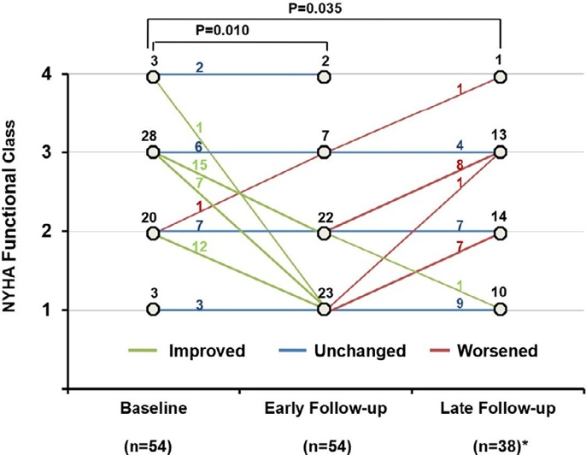

Response to CRT with a ≥ 5% increase in LVEF or RVFAC was seen in 65%. Most responders had a systemic LV (74%) compared to systemic RV (40%). There was significant improvement in ejection fraction at both the early and late period for systemic left ventricles. However, there was no significant improvement in RV fractional area change in the systemic right ventricles. See figures below.

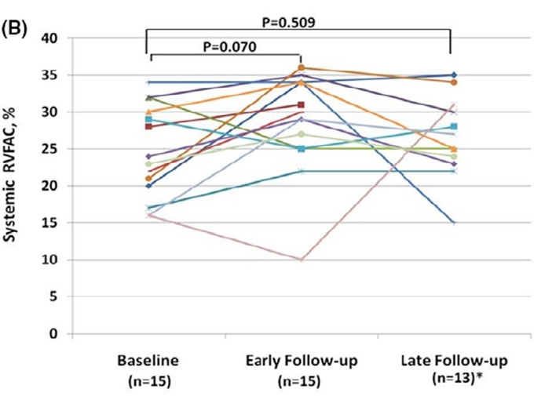

On further echocardiographic assessment of systemic left ventricles, improved LVEF and LV End systolic volume persisted in Late Period follow-up.

On further echocardiographic assessment of systemic right ventricles, there was no significant improvement in RV function that persisted in the Late Period follow-up.

Predictors of CRT response on multivariate analysis showed only baseline QRS duration was a significant predictor (OR: 1.4 per every 10-msec increase in QRS duration; 95% CI, 1.042– 1.838; p= 0.025). The QRS duration for responders vs non-responders was 182 ±23 msec vs. 159 ± 29 msec (p<0.007). There was no difference in QRS duration in those without or without a pre-existing pacemaker and prior pacemaker was not shown to be a risk factor. See figure below.

Overall, 20% died from all-cause mortality between 4.2 and 11.8 years after CRT. Below are
Kaplan-Meier curves depicting freedom from death and heart transplantation from CRT in patients with systemic left and right ventricles. Of note, 2 patients listed for transplant were removed from the list due to clinical improvement with CRT.

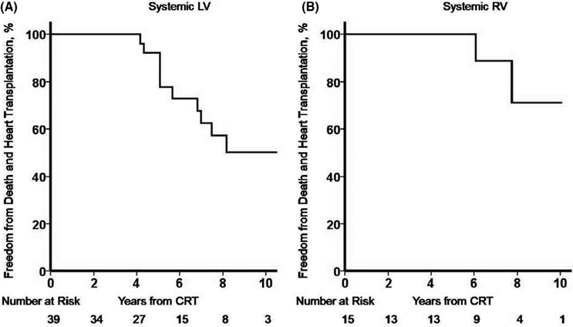

This study demonstrates the efficacy of CRT in an older cohort of heterogenous ACHD patients with improvement in both NYHA Functional Class and systemic ventricular function. The design of this study allowed for analysis of early and late effects of CRT which had not previously been reported.
The improvements in ventricular function were seen at both short and long-term follow-up in those with systemic left ventricles but were not seen in those with systemic right ventricles. This lack of response may be reflective of the small sample size, heterogeneity of cardiac lesions, or ventricular morphology. Overall, the majority of patients had an improvement (65%) or no change (33%) in NYHA Class early after CRT but a subsequent decline in NYHA Class was seen overtime in 31% raising concern for the long-term effectiveness of CRT in these patients.
The response to CRT was dependent on QRS duration consistent with data from adults without ACHD. However, bundle branch block morphology was not associated with response. In addition, left ventricular morphology plays an important role in those with the highest likelihood to respond.
Despite the positive effects of CRT in this population, 20% died of all-cause mortality. Identifying and improving methods to treat heart failure in the ACHD population is therefore critically important.
This study raises the importance of using CRT in ACHD with systemic ventricular dysfunction and heart failure. In particular, the study demonstrated minimal deleterious effects on cardiac function with significant potential benefits. Clearly there are important anatomic and procedural aspects to consider as device complications were seen in 19%. However, increased experience should result in reducing these issues.
Ultimately, more data is needed with larger sample sizes, more homogenous populations, and longer term follow-up to determine the response to CRT and better identify predictors to refine existing guidelines. In addition, the cohort in this study focused only on the failing systemic RV and LV in biventricular circulation. Further consideration is needed in those with failing single ventricles (RV vs. LV) or failing subpulmonary ventricles.
Management of heart failure in ACHD patients is important to reduce deaths, need for transplantations, reduce comorbidities, need for hospitalization, and improve quality of life. Similar to this study, a multidisciplinary individualistic approach is needed when determining CRT placement in ACHD patients until additional data is available.

