Elevated non-invasive liver fibrosis markers and risk of liver carcinoma in adult patients after repair of tetralogy of Fallot.
Yamamura K, Sakamoto I, Morihana E, Hirata Y, Nagata H, Yamasaki Y, Okumura Y, Kohashi K, Koto K, Tsutsui H, Ohga S.
Int J Cardiol. 2019 Jul 15;287:121-126. doi: 10.1016/j.ijcard.2019.04.032. Epub 2019 Apr 11.
PMID: 31006598

Take Home Points:
- Liver fibrosis increases the risk of cardiac operation with cardiopulmonary bypass especially if it is associated with thrombocytopenia and/or coagulopathy.
- Elevated liver fibrosis markers due to hepatic congestion is present not only in adult patients after Fontan procedure but also after TOF repair.
- However, RV dysfunction and liver congestion could be resolved by pulmonary valve replacement in rTOF
- Careful monitoring of the liver fibrosis markers and reoperation at an appropriate time may be beneficial in improving the long-term outcomes in rTOF patients with elevated right atrial pressure.

Commentary by Dr. Soha Romeih (Aswan, Egypt), section editor of ACHD Journal Watch: In Fontan patients, the elevated systemic venous pressure leads to hepatic congestion and hepatic fibrosis. Chronic RV dysfunction and hepatic congestion develops over time and may lead to liver fibrosis, and subsequent development of liver cirrhosis late after repair of TOF (rTOF). However, the incidence and severity remain unclear.
This study aimed to elucidate the incidence and severity of liver fibrosis in patients with rTOF. 50 TOF patients with PR/PS, 50 age-matched patients after Fontan procedure, and 11 control subjects were enrolled. Patients who had other forms of liver diseases, such as viral hepatitis or alcoholic liver disease were excluded. In all patients, liver fibrosis markers (hyaluronic acid and type IV collagen), hemodynamic parameters obtained from CMR and cardiac catheterization, and abdominal ultrasonography and liver biopsy data were documented.
Hyaluronic acid levels in patients with rTOF were significantly higher than controls, and were lower than those after Fontan palliations. Type IV-collagen levels in patients with rTOF were higher than controls, and tended to be lower than those after Fontan. Patients with rTOF showed abnormal hyaluronic acid levels more frequently than controls, and less frequently than those after Fontan.

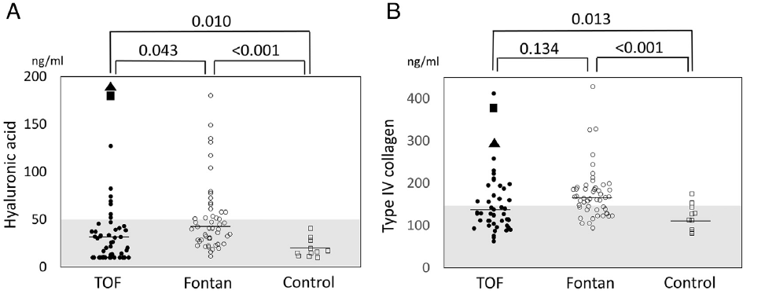
In patients with rTOF, hyaluronic acid levels correlated positively with time after repair (r= 0.39, p =0.005) and type IV collagen levels correlated positively with RA pressure (r=0.42, p= 0.007). On the other hand, in patients after Fontan, liver fibrosis markers showed no significant correlation with time after surgery or RA pressure.

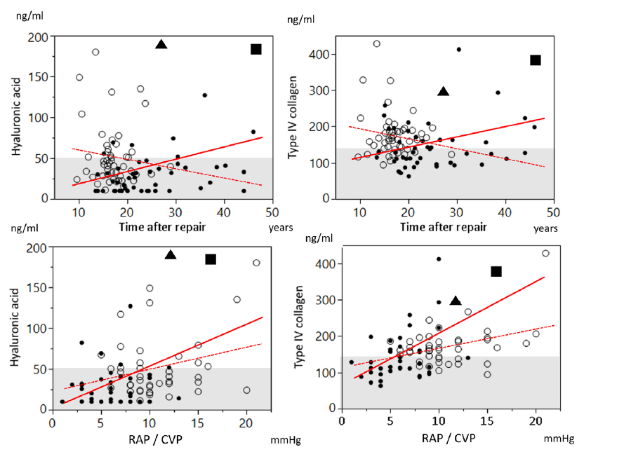

Type IV-collagen levels in patients with rTOF with moderate or severe TR (n = 13) was higher than those with less than moderate TR (n = 37). Other than that, there was no difference in type IV-collagen or hyaluronic acid levels among patients with PR, PR + PS, and PS, between patients with and without moderate or severe TR or between patients with and without restrictive RV physiology.
Patients with hepatic congestion on abdominal ultrasound had significantly higher type IV collagen, higher total bilirubin, lower total protein, lower platelet count and higher RV end-diastolic pressure than those without hepatic congestion (p b 0.05, respectively).
23 patients with rTOF underwent PVR and 13 of them received the assessment of fibrosis markers after PVR. Liver fibrosis markers did not show statistically significant decrease after PVR in this small number of subjects (hyaluronic acid: median, 32 to 28 ng/mL, p = 0.588; type IV collagen: median 145 to 124 ng/mL, p =0.105). However, 12 patients (92%) and 10 patients (77%) had normalization of the hyaluronic acid and type IV collagen levels after PVR.
Elevated RA pressure and pulmonary regurgitant fraction had an association with elevated type IV collagen.
Although the predictive value of serum markers for liver fibrosis is not completely validated with comprehensive imaging tests or liver biopsy in this population, this association indicates the fibrosis markers should reflect the degree of liver fibrosis due to elevated RA pressure.

There are several limitations about this study: the study population is relatively small, especially in patients who underwent imaging tests and biopsy of the liver, cardiac catheter data in the controls and CMR data in the Fontan patients and controls were not available in the majority of subjects because of the retrospective data collection, and there was no data to investigate the relationship between elevated liver fibrosis markers and prognosis. A prospective study with a larger population is needed to determine the clinical impact of elevation of these fibrosis markers.

