Leaflet morphology classification of the Melody Transcatheter Pulmonary Valve.
Boe BA, Cheatham SL, Armstrong AK, Berman DP, Chisolm JL, Cheatham JP.
Congenit Heart Dis. 2019 Mar;14(2):297-304. doi: 10.1111/chd.12728. Epub 2018 Dec 13.
PMID: 30548926
Similar articles
Select item 30506893

Take Home Points:
- The Melody transcatheter pulmonary valve is made from a bovine jugular vein sutured onto a stent.
- There are variations in the valve morphology.
- Midterm outcomes for all valve morphologies are excellent. However, longer term outcomes and differences in outcomes of valve function and complications based on valve morphology remain unknown.

Commentary by Dr. Ryan Romans (Kansas City), section editor of Interventional Cardiology Journal Watch: The Melody Transcatheter Pulmonary Valve (TPV) was first implanted as a treatment for right ventricular outflow tract (RVOT) conduit dysfunction in 2000 and in the United States in 2007. Since then, use of the Melody valve has expanded to include placement in bioprosthetic valves in the tricuspid (off label) and pulmonary positions (valve in valve) and in native RVOTs (such as tetralogy of Fallot s/p repair with a transannular patch, also off-label). The Melody valve is constructed from a bovine jugular vein sutured within a platinum/iridium stent. The bovine jugular vein has thin leaflets with deep commissures making it ideal for implantation over a wide range of geometric configurations and implanted diameters. All valves are rigorously tested prior to release for clinical use and all bicuspid valves are discarded. However, variations in valve morphology have been noted but never described.

Boe et al performed a single center retrospective study to evaluate the different Melody TPV morphologies. Their institution routinely captures intraprocedural down-the-barrel videos and photographs of the Melody TPV to assess leaflet appearance. A random cohort of Melody TPV images were reviewed and used to create a morphologic classification system as shown below.
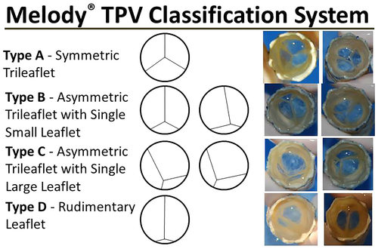

All of the Melody valves were then blindly reviewed and classified by all 5 implanters, with the final classification assigned based on the consensus (classification assigned by 3 or more reviewers).
Over a 5-year period, a total of 62 valves were implanted in 61 patients. Type A morphology was seen in 48% of valves, type B in 32%, type C in 16%, and type D in 5%. Follow up data at 6-months was available for 41/55 Melody valve implantations (7 patients were excluded for outcomes analysis due to the valve being implanted in a non-pulmonary position). Acceptable hemodynamic function (defined in the Melody Post-Approval Study as a mean RVOT gradient of 30 mmHg or less and mild regurgitation or less) at 6 months post implantation was seen in 40/41 valves. Over a median follow-up period of 1.5 years (range 0-4.4), only 2 of the Melody valves developed greater than mild regurgitation, with both valves being type A. Complications were seen in 9 valves implanted in 8 patients during follow up. There were 3 cases of endocarditis (all requiring Melody valve explantation), two valves with frame fracture, one case of refractory arrhythmias (patient with multiple pre-stents) requiring surgical pulmonary valve replacement, two patients requiring conduit replacement due to Melody valve stenosis, and one death. 4 of the complications occurred with type A valves and 5 with type B.

This is the first description of Melody TPV morphology. This study was not sufficiently powered to adequately assess outcomes between valve morphologies. However, all valve types had excellent midterm function and low complication rates. Future prospective studies may offer better understanding of outcomes based on valve morphology.

