Multimodality Screening of Hepatic Nodules in Patients With Congenital Heart Disease After Fontan Procedure: Role of Ultrasound, ARFI Elastography, CT, and MRI.
Horvat N, Rocha MS, Chagas AL, Oliveira BC, Pacheco MP, Binotto MA, Ikari NM, Paranaguá-Vezozzo DC, Leao-Filho HM, Vicentini JRT, Moreira da Silva Filho MR, Jatene MB, Carrilho FJ, Cerri GG.
AJR Am J Roentgenol. 2018 Dec;211(6):1212-1220. doi: 10.2214/AJR.18.19762. Epub 2018 Sep 24.
PMID: 30247977
Similar articles
Select item 30343246

Take Home Points:
- In a series of asymptomatic Fontan patients, hepatic nodules were found on screening in 6.1%, 31.8%, and 39.6% respectively on US, CT and MRI.
- There was an almost perfect agreement between CT and MRI.
- No correlation was found between the presence of hepatic nodules and clinical or laboratory data.
- Liver stiffness on ARFI was a significant predictor of hepatic nodules (AUC 0.767, p=0.0002).
- For ARFI, a cut-off of 2m/s has a sensitivity of 78.9% and a specificity of 67.9%.

Commentary by Dr. Blanche Cupido (Cape Town), section editor of ACHD Journal Watch: Fontan liver disease is thought to be multifactorial and may result in liver fibrosis, cirrhosis with or without portal hypertension, hepatic nodules and even hepatocellular carcinoma. There is no consensus regarding the screening for liver pathology, especially with regards to imaging after a Fontan procedure.

This is a single-center cross-sectional study of patients with a Fontan circulation. They aimed to assess the presence of hepatic nodules by US, CT ad MRI, to measure liver stiffness and to identify factors predictive of nodules. Patients were recruited between August 2014 to June 2016. Pregnant patients and those who could not undergo CT or MRI were excluded.
Forty-nine patients were included – they underwent a hepatology clinical consult, upper abdominal US, liver acoustic radiation force impulse (ARFI) elastography, upper abdomen triple-phase CT and MRI on the same day. Cardiology data was reviewed retrospectively.
Of the 49 patients, 57.1% were female. The mean age was 26.2 years. Patients were mostly asymptomatic (2 had ascites). All patients had normal levels of alpha-fetoprotein.
Hepatic nodules were found in 3 of 49 patients on US (6.1%), in 14 of 44 patients (31.8%) on CT and in 19 of 48 patients (39.6%) on MRI. All nodules were <3cm in size. None of the nodules displayed features of malignancy.
There were no clinical differences between the patients with hepatic nodules and those without (i.e. no difference in terms of time since Fontan procedure, no difference with regards to the type of Fontan, the presence of a fenestration).
With regards to liver stiffness, mean velocities at ARFI were significantly higher in those with hepatic nodules compared to those without (2.64 m/s vs 1.94m/s, p=0.002). It was significantly lower in those who had heart transplants (0.93 vs 2.28m/s, p=0.002).

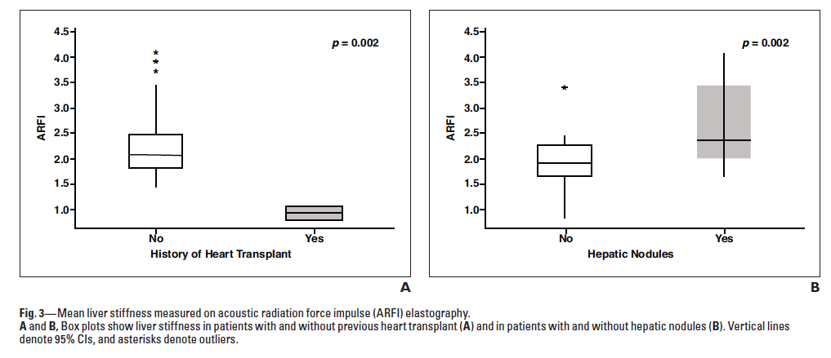

Shear-wave propagation velocity at ARFI elastography was a significant predictor of the presence of hepatic nodules – AUC 0.767 (p=0.002). By using a cut-off of 2m/s, ARFI had a sensitivity of 78.9% and a specificity of 67.9%.

