Here today, gone tomorrow: Outcomes of residual leak following secundum atrial septal defect closure with the GORE CARDIOFORM Septal Occluder.
Gordon BM, Abudayyeh I, Goble J, Collado NA, Paolillo J.
Catheter Cardiovasc Interv. 2019 Dec 26. doi: 10.1002/ccd.28666. [Epub ahead of print]
PMID: 31876383
Similar articles
Select item 31909179

Take Home Points:
- The GSO is safe and effective in closing small to moderate atrial septal defects.
- Small residual defects are fairly common (17.6%), especially in larger defects, multifenestrated defects, and those with a deficient retroaortic rim.
- The large majority of these residual defects (87.6%) are not seen by transthoracic echocardiography at 1 year follow up.

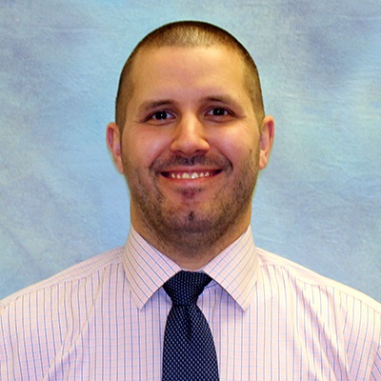
Commentary from Dr. Ryan Romans (Kansas City, MO), section editor of Congenital Heart Disease Interventions Journal Watch: Transcatheter device closure of atrial septal defects (ASDs) is well accepted as the first-line treatment option in amenable defects. The GORE CARDIOFORM Septal Occluder (GSO) received CE mark in June of 2011. The GSO is made of five nitinol wires with a platinum core wires that create a double disc frame composed of 10 petals (5 on each side) covered by an expanded polytetrafluoroethylene (ePTFE) membrane. It can be used to close secundum atrial septal defects up to 17-18 mm in size. The GSO is different from other ASD closure devices available in that it is a nonself-centering device that just has a central eyelet connecting the two discs. It depends on an adequate device to defect ratio to completely cover the ASD while allowing for endothelialization. Other ASD closure devices have a central waist embedded with fabric to promote closure that fills the ASD (self-centering device). Because the device does not have a central waist to fill the defect and keep it centered within the ASD, it can shift after placement to conform to the septal anatomy. This could potentially lead to small leaks around the device.

In order to evaluate the frequency of residual defects immediately after placement and medium term outcomes of these residual defects, Gordon et al performed a retrospective review of all patients who underwent ASD closure with a GSO as part of the pivotal and continued access U.S. trials. There were 370 total ASD device closures with the GSO. Of these, 65 (17.6%) had a residual leak. 4 patients with a residual leak were excluded from analysis (3 for inadequate device position on review of the echocardiogram, 1 who had a satellite defect not in contact with the device). Patients who had a residual leak were more likely to have larger defects (10.33 ± 3.05 mm versus 9.13 ± 2.89 mm), smaller retroaortic rims (4.87 ± 3.33 mm versus 6.17 ± 3.78 mm), and a multifenestrated defect. These patients were also more likely to have had transesophageal echocardiography to guide closure (TEE likely visualizes the entire atrial septum more thoroughly than transthoracic echocardiography and intracardiac echocardiography), longer fluoroscopy times, larger devices implanted, and more devices per procedure utilized. At 1 year follow up (routinely performed as part to the trial), there was a decrease in the size of the defect from 1.55 ± 0.75 mm to 0.25 ± 0.74 mm with the majority of residual defects (87.6%) no longer seen.
The GSO has been shown to be safe and extremely effective for closure of small-moderate sized secundum ASDs. This study shows that small residual leaks are fairly common after device implantation but that the large majority of these are not seen at 1 year follow up. Larger defects, deficient retroaortic rims, and multifenestrated defects are more likely to have a residual defect at the time of implantation. The authors hypothesize that resolution of the defects may be due remodeling and subsequent normalization of the right atrial size after the volume load from the ASD is removed. This decrease in size may allow more of the device to come in contact with the surrounding tissue and promote endothelialization. They note that in larger defects with deficient retroaortic rims they will often implant a larger device than may be needed based on the ASD size if the total septal length and LA size will allow it (I have adopted and had success with this practice as well). Overall, the device has excellent an excellent mid-term outcome of complete closure of the ASD.

