Safety and effectiveness of home-based, self-selected exercise training in symptomatic adults with congenital heart disease: A prospective, randomised, controlled trial.
van Dissel AC, Blok IM, Hooglugt JQ, de Haan FH, Jørstad HT, Mulder BJM, Bouma BJ, Winter MM.
Int J Cardiol. 2019 Mar 1;278:59-64. doi: 10.1016/j.ijcard.2018.12.042. Epub 2018 Dec 17.
PMID: 30594347
Similar articles

Take Home Points:
- Physical exercise is generally safe in symptomatic patients with congenital heart disease.
- Patients with complex congenital heart disease demonstrate more improvement than those with moderate congenital heart disease after undergoing exercise training.

Commentary from Dr. M.C. Leong (Kuala Lumpur), section editor of ACHD Journal Watch: Exercise training programmes have been shown to improve exercise capacity and the quality of life of patients with congenital heart disease (CHD). However, its effect on symptomatic patients with CHD is largely unknown. No study so far, has elucidated the beneficial or harmful effects of exercise training in this group of patients. This study aimed to evaluate the safety and efficacy of home based, unsupervised, self selected, execise training in symptomatic patients with CHD over a period of 6 months.

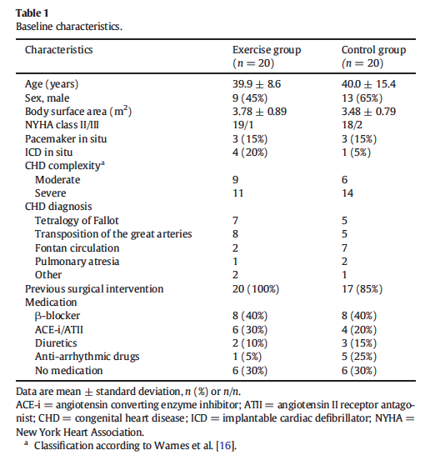
This is a prospective, single centre, parallel group, randomised controlled trial which assigned 40 patients with NYHA II or III into two groups i.e the exercise group or the controlled group. Patients in the exercise groups were prescribed with exercise of a minimum of 3 sessions of 45 minutes. Patients in the controlled group were not prescribed with any exercise training. All patients were asked to continue habitual daily activities, even if these included regular physical exercise.

During the study period, no patient experienced cardiac related events. There is a mariginal but statistically significant improvement in the peak VO2 in the exercise group by +1.6 ± 2.7ml/kg/min. The improvement is seen more in patients with severe CHD complexity compared to those with moderate CHD complexity (mean change : +3.0 ± 1.9 vs. −0.04 ± 2.5 ml/kg/min, p = 0.012). Meanwhile the control group showed no improvement in the peak VO2. The NTproBNP levels and the quality of life was measured subjectively via questionaires before and after study period – this remained unchanged in both groups.
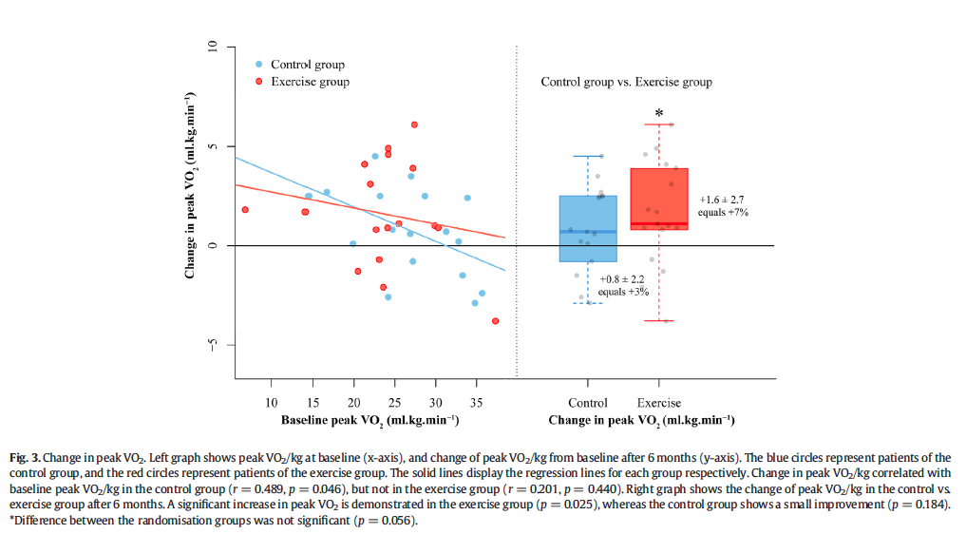
Although this study did not show a marked improvement in the exercise capacity in the exercise group, it has demonstrated that exercise in patients with congenital heart disease, even if they are in NYHA II or III, is safe. This will hopefully allay the concerns of the patients and the caregivers alike, on physical activities in this group of patients.

