The entirely subcutaneous ICDTM system in patients with congenital heart disease: experience from a large single-centre analysis.
Willy K, Reinke F, Bögeholz N, Köbe J, Eckardt L, Frommeyer G.
Europace. 2019 Jul 13. pii: euz190. doi: 10.1093/europace/euz190. [Epub ahead of print]
PMID: 31302706
Similar articles
Select item 31302722

Take Home Points:

- ACHD patients who are not candidates for transvenous systems (i.e. cyanotic or single ventricular heart disease) are overrepresented in cohorts of ACHD SICD studies such as this one.
- The SICD appears to be effective and safe in the ACHD population, with an acceptable rate of inappropriate shocks during short term follow up.
- The long-term outcome of ACHD patients undergoing SICD placement is not well-described and larger studies are still needed.

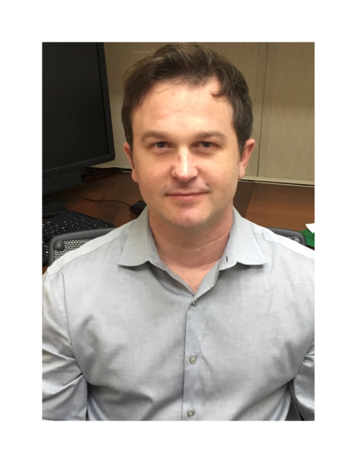Commentary by Dr. Jeremy Moore (Los Angeles) Congenital and Pediatric Cardiac EP section editor: This was a single-center retrospective study evaluating the authors’ experience with the SICD in 20 patients with adult congenital heart disease. The first SICD was implanted at this center in June 2010, shortly after the CE mark approval in Europe. The mean age was 40.5 ± 11.5 years and the youngest patient was 19 years of age. The SICDs were implanted in a heterogenous population of ACHD patients, however at least 5 (25%) patients had single ventricle anatomy and 3 (15%) were palliated and/or cyanotic. Device implantation was most commonly secondary prevention in 70% and primary prevention in 30%. Only one patient had a preexisting cardiac device at the time of implant. Acute testing was notable for successful defibrillation in 18 of 20 at 65J, one at 70J, and deferred in one.

The study follow up period was 3 years, during which time 3 (15%) patients experienced appropriate shocks and 2 (10%) experienced inappropriate shocks (IAS). Appropriate shocks for monomorphic VT were observed in one TOF and one DTGA-Mustard patient, and multiple appropriate shocks for polymorphic VT were observed in a patient with HLHS who had undergone a TCPC operation. IAS were due to T wave oversensing in both cases, and could be avoided with programming changes (i.e. One managed by changing the sensing vector, the other by turning on SMARTPASS filter). During follow up, 3 patients died from non-arrhythmic causes. One system required explantation for wound infection that could not be treated with antibiotics.
Although this is not the largest study of the SICD in ACHD to date, this report benefits from nearly complete data acquisition and relatively long follow up, compared to other similar studies. Overall, this report supports the SICD as a useful technological strategy for ACHD patients, particularly those with single ventricle anatomy or cyanotic congenital heart disease as demonstrated previously.¹ As opposed to other similar studies in this population, issues such as concomitant cardiac electronic devices (common in the Fontan population) and IAS were less commonly seen. As for the latter, recent improvements in this technology such as improvements in bandpass filtering, may partially explain this discrepancy. Also, the absence of unprotected brady-asystole was not observed in this study, which is encouraging (although implanters should remain vigilant for this possibility).
- Moore JP, Mondésert B, Lloyd MS, Cook SC, Zaidi AN, Pass RH, John AS, Fish FA, Shannon KM, Aboulhosn JA, Khairy P; Alliance for Adult Research in Congenital Cardiology (AARCC). Clinical Experience with the Subcutaneous Implantable Cardioverter-Defibrillator in Adults with Congenital Heart Disease. Circ Arrhythm Electrophysiol. 2016 Sep;9(9). pii: e004338. doi: 10.1161/CIRCEP.116.004338.

