The long-term functional outcome in Mustard patients study: Another decade of follow-up.
Srivastava NT, Hurwitz R, Kay WA, Eckert GJ, Kuhlenhoelter A, DeGrave N, Ebenroth ES.
Congenit Heart Dis. 2019 Mar;14(2):176-184. doi: 10.1111/chd.12698. Epub 2018 Nov 23.
PMID: 30468301
Similar articles

Take Home Points:
- Cardiac mortality (death or transplant) is high in D-TGA patients treated with the Mustard atrial switch procedure, followed longitudinally over several decades, with half of the events occurring after age 25.
- The majority of deaths were due to systemic RV failure rather than sudden cardiac death.
- 3/8 patients with sudden cardiac death (excluding those post-transplant) had no prior history of arrhythmia during routine follow up.
- Systemic RV function showed a progressive decline over longitudinal follow up, whereas sub-pulmonary LV function was maintained.
- The majority of patients demonstrated some degree of arrhythmia.
- Few patients required pacemaker due to sinus node dysfunction/sick sinus syndrome beyond 2-3 decades post-surgery.
- General health, physical function and energy were significantly reduced in quality of life questionnaires.
- There was no single clear predictor for worse outcomes in D-TGA Mustard patients, although deteriorating RVEF is associated with mortality and transplantation.

Commentary from Dr. Timothy Roberts (Melbourne), section editor of ACHD Journal Watch: This longitudinal cohort study from the Indianapolis group provides an update on the outcome of D-TGA Mustard patients over two decades after their atrial switch operation. A total of 45 patients were originally included for assessment between 1993-97 (Time 1), with 35 agreeing to be included approximately 10 years later (Time 2). In the current follow up assessment performed between 2013-17 (Time 3), 25 of the original 45 participants data are included (figure 1, below). This group comprises 16 males and 9 females, at a mean age of 36.7 +/- 4.9 years (29 – 49 years), 34.3 +/- 3.9 years post original Mustard repair.

Figure 1.
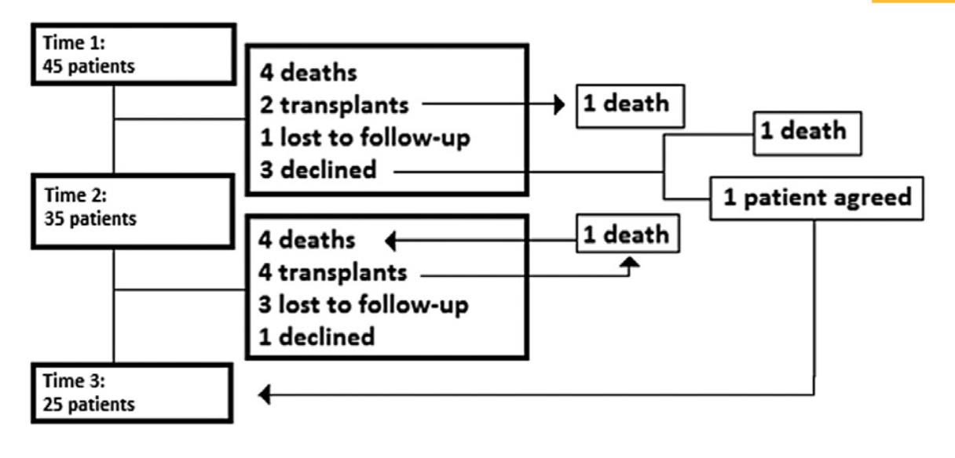
Testing involved a standard Bruce protocol treadmill cardiopulmonary exercise test (CPET), echocardiography, Holter monitor with rhythm history, and quality of life questionnaire. Cardiac function and anatomy were assessed by cardiac MRI or cardiac CT, rather than radionuclide angiocardiography as was performed in the original study.
Mortality at any time point after recruitment (Time 1) was 22% (10/45 patients). Four of these (9%) occurred between Time 1 and Time 2, while a further six (13%) died between Time 2 and Time 3. Six patients underwent cardiac transplantation, two prior to, and four after, Time 2. Two of these transplant patients subsequently died of acute rejection, leaving a total of 14 patients (31%) of the original patient cohort experiencing cardiac death (mortality, cardiac transplantation, or both).
Fifteen (63%) of 23 patients with rhythm data available demonstrated some form of continued rhythm disturbance. Seven of the 23 had required pacemaker insertion for sick sinus syndrome or complete heart block, however only one required pacing between Times 2 and 3. Five (23%) had undergone cardioversion, and 5 (23%) required EP study for either supraventricular or ventricular tachycardia.

Exercise time and workload (METS) reduced significantly between Time 1 and 2, but no further significant reduction was observed in the follow decade (figure 2). VO₂peak reduced from 28 (+/- 6.7) ml/kg/min to 23.6 (+/- 7.8) ml/kg/min between Time 2 and 3, which did not meet statistical significance and furthermore data corrected for age-predicted measures (noting the 10-year period between results) was not provided. Maximum predicted heart rates did not differ over the three time points, although they were lower than would be expected for a healthy cohort.
Figure 2.
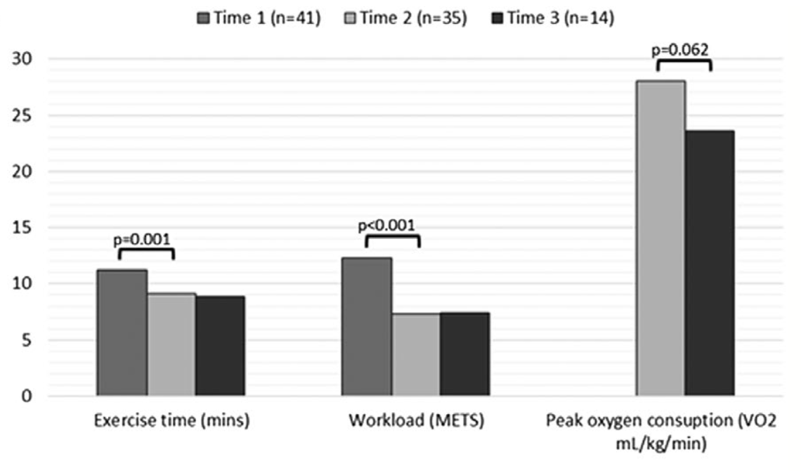

Cardiac CT or MRI was performed in 34/35 subjects at Time 2, and 18/25 subjects most recently. RVEF decreased significantly to 45% (+/- 11%) vs. 53% (+/- 10%) at Time 2 (P=0.011). LVEF was unchanged (62 +/- 8% vs. 62 +/- 8%; P=0.868). Subjective assessment of RV function by echocardiography was made in 21/25 patients, and compared to previous data of the same patients at Times 1 and 2. Three (14%) patients in the current study had normal RV function, compared to 26% at Time 2, and 29% at Time 1.
Anatomical assessment identified 71% with patent systemic and pulmonary baffles, 14% with mild SVC baffle obstruction, and 14% with significant or severe baffle obstruction. None of the subjects with baffle obstruction had documentation of baffle obstruction in their previous assessment at Time 2.
Quality of life questionnaires noted progressive decline in energy during the three Time points. General health, physical function, and energy were statistically different as compared with healthy adult norms. Additionally, scores were comparable or lower in all areas as compared to those with other forms of acyanotic congenital heart disease.

The study group appropriately conclude that cardiac mortality remains high for Mustard patients over two decades of longitudinal follow-up, while systemic RVEF, exercise tolerance, and quality of life measures decline. No single predictor was identified to predict a poorer outcome, although deteriorating RVEF was associated with mortality and cardiac transplantation.

